**DataNexus - Unity Catalog for Databricks**

Revision / Document History

|  |  |  |  |  |  |
| --- | --- | --- | --- | --- | --- |
| **Ver.** | **Modification**  **Date** | **Reviewed Date** | **Changes by** | **Reviewed By** | **Modifications** |
| 1.0 | 23-01-2024 | 23-01-2024 | Bandi Naveen (SX/BSV-TC1) | Begum Munwari (SX/ETL2) | Initial Version |
| 1.2 | 24-01-2024 | 25-01-2024 | Prashant Pathak (SX/ETL2) | Begum Munwari  (SX/ETL2) | Updated the document for cluster creation and catalog creation by using external locations. |
| 1.3 | 24-01-2024 | 25-01-2024 | Akshata Patil  (SX/BSV-TC1) | Begum Munwari  (SX/ETL2) | Updated the document with steps to configure RLS, CLS and Table Level Access control. |
|  |  |  |  |  |  |

**DataNexus - Unity Catalog for DataBricks**

DataNexus - Unity Catalog for Databricks 1

1. MetaStore setup: 2

2. Creation of Interactive Cluster: 9

2.1 Creation of Single node Interactive Cluster: 10

2.2 Creation of Multinode single user interactive cluster: 19

3. Creation of Catalog: 30

3.1 Creation of catalog using python script: 30

3.2 Manual steps in case of difficulty with the script : 34

4. Creation of Schemas Based on Source System: 41

5. Creation of User groups 48

6. Add User to Users groups: 52

7. Providing Access to user group on Data Object : 55

8. Creating Service Account: 64

9. Creating job for Service account: 65

10. Testing RLS and CLS after running the jobs: 67

11. ETL Pipeline Changes 70

12. Extended Insights: Exploring Advanced Cluster Options: 71

12.1 Creation of Interactive Cluster(shared): 71

12.2 Creation of Job Cluster: 76

12.3 Cluster Pools 86

**Unity Catalog**

Please follow below mentioned steps to setup unity catalog in databricks.

1. MetaStore setup:
2. Login to Azure portal with the required credentials-> Click on **fofprdeusdata** storage account

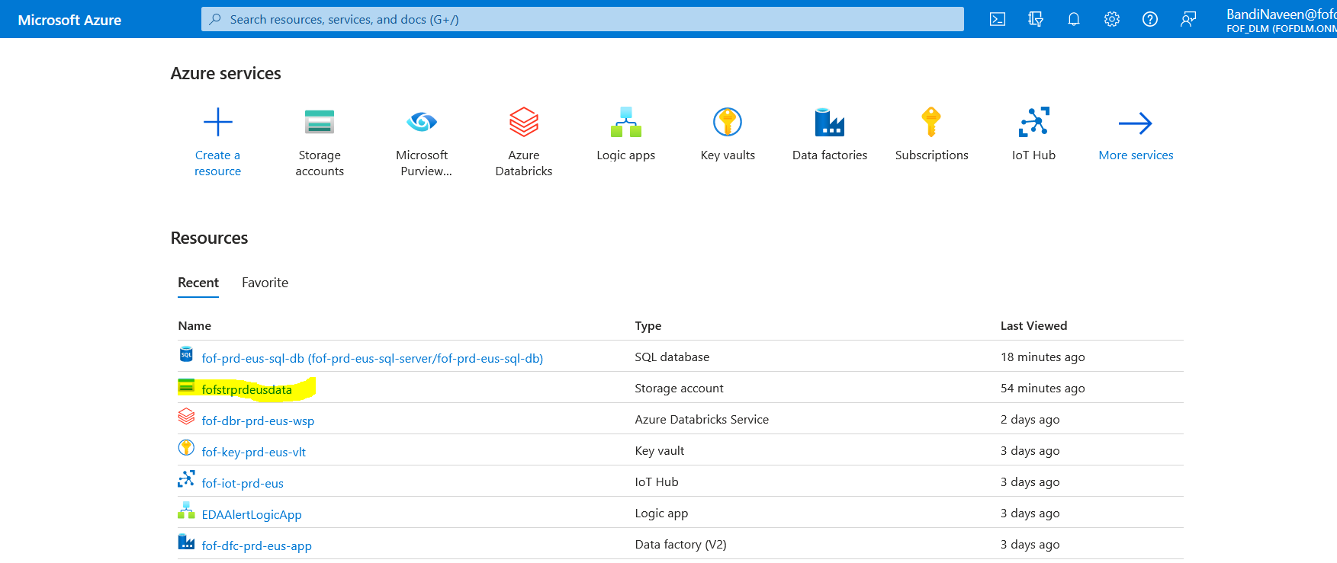

1.2 Navigate to Containers -> Click on +container

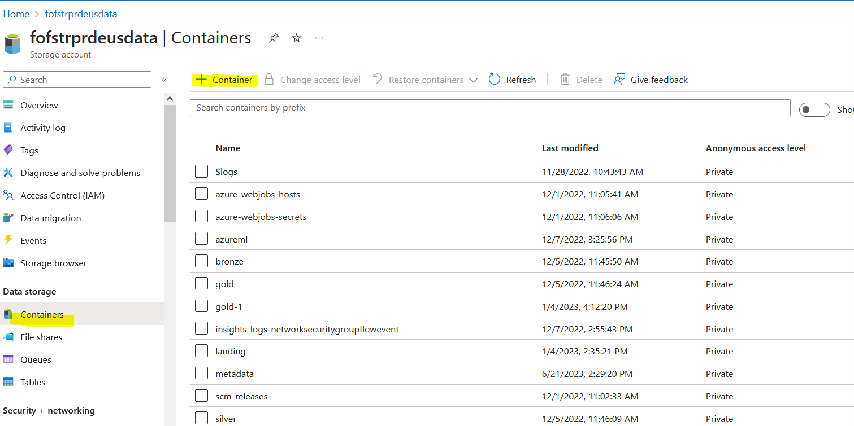

1.3 Mention container name and -> click on create

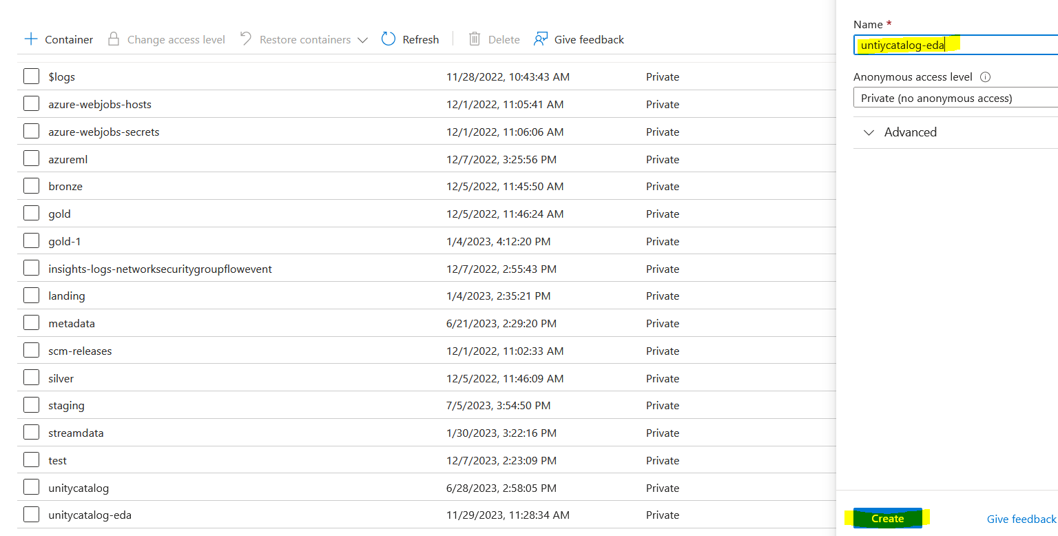

1.4 Go back to Home page click on **+create resource**

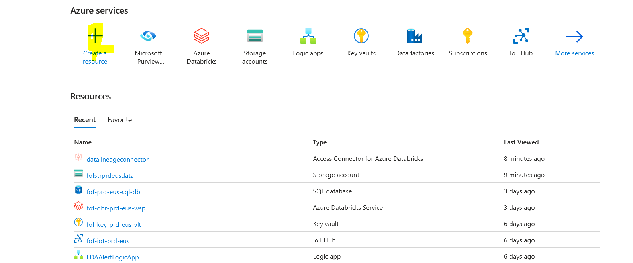

1.5 On marketplace search for Access Connector for azure databricks

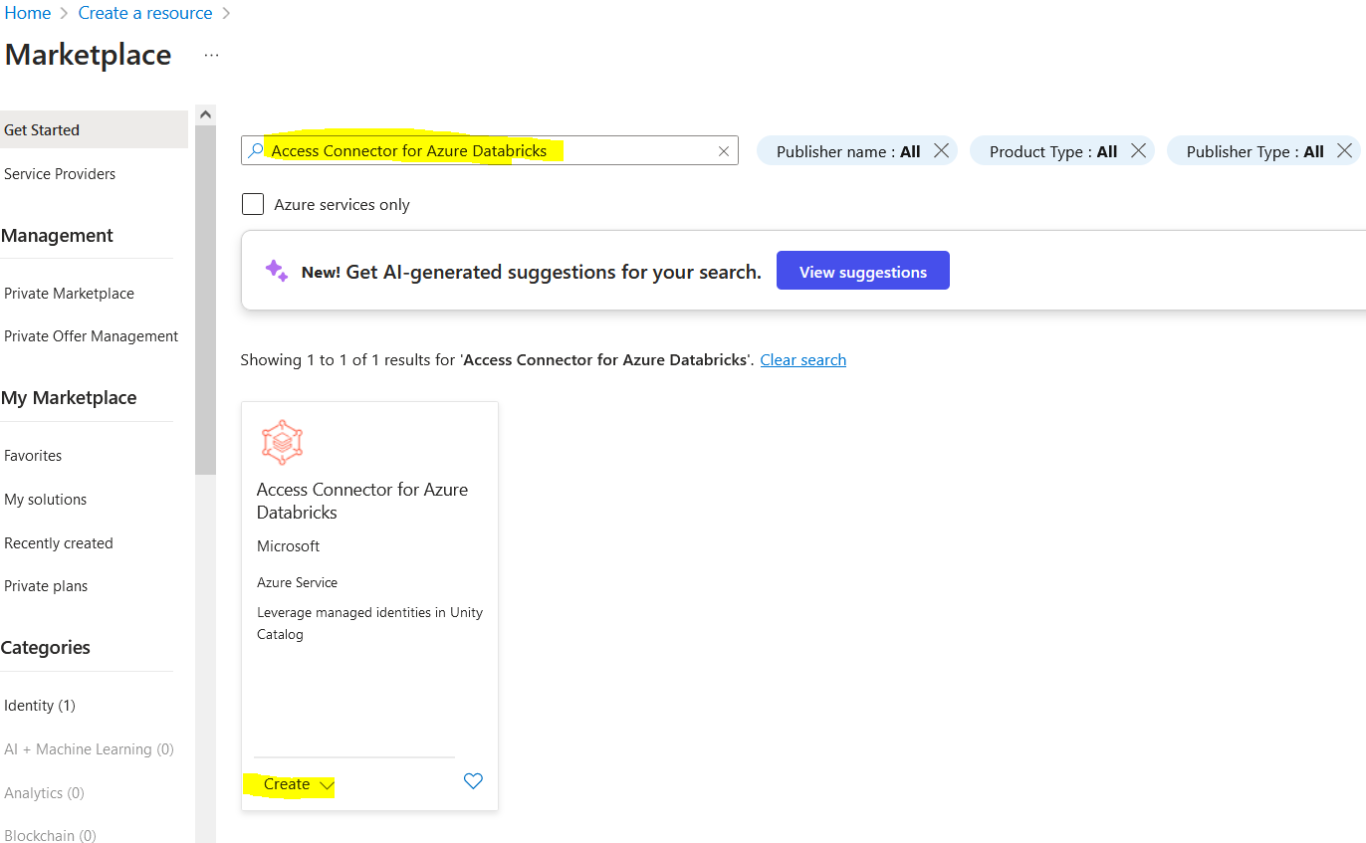

1.6 Fill the required details and click on **Review+Create**

Note : Azure Databricks and Access connector for Azure data need to be on same region

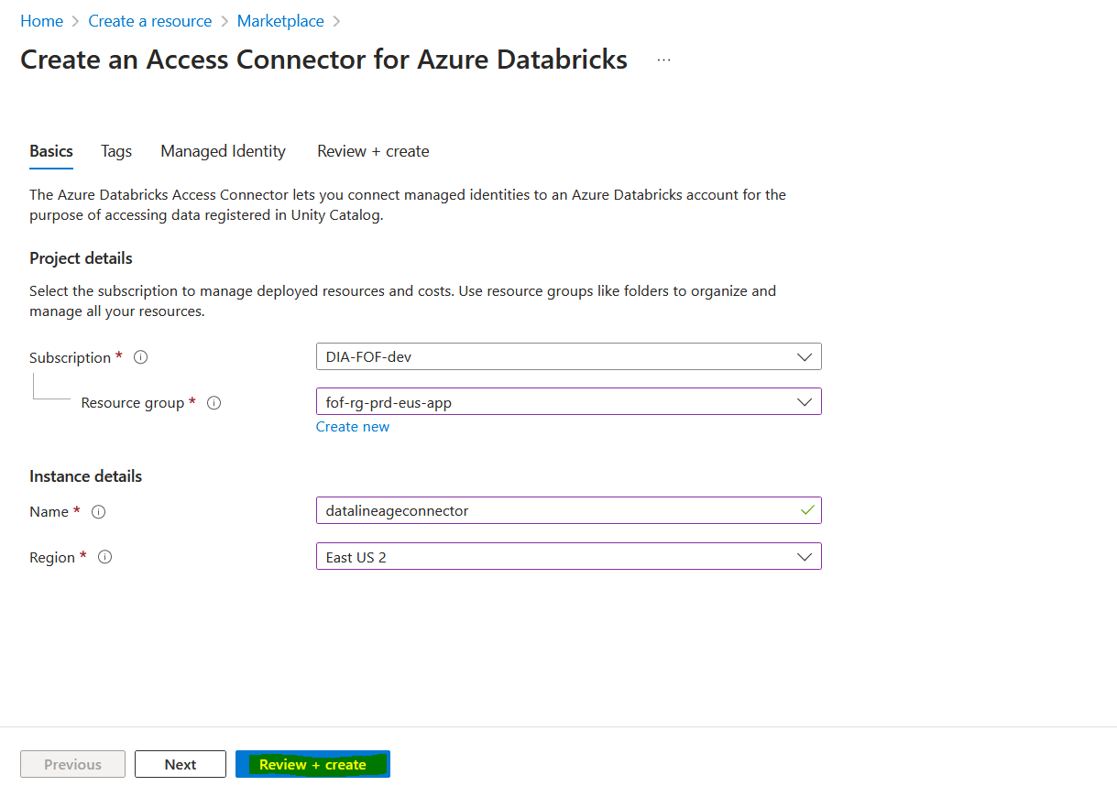

1.7 Go back to home page search for Access connectors for Azure databricks

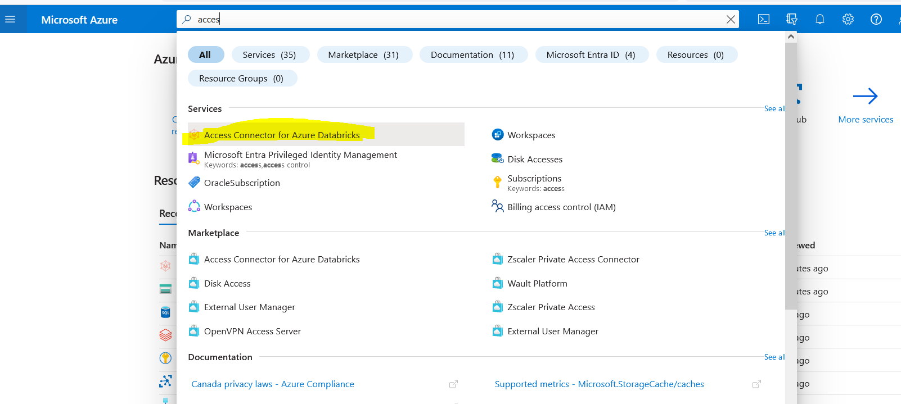

1.8 Click on datalineageconnector

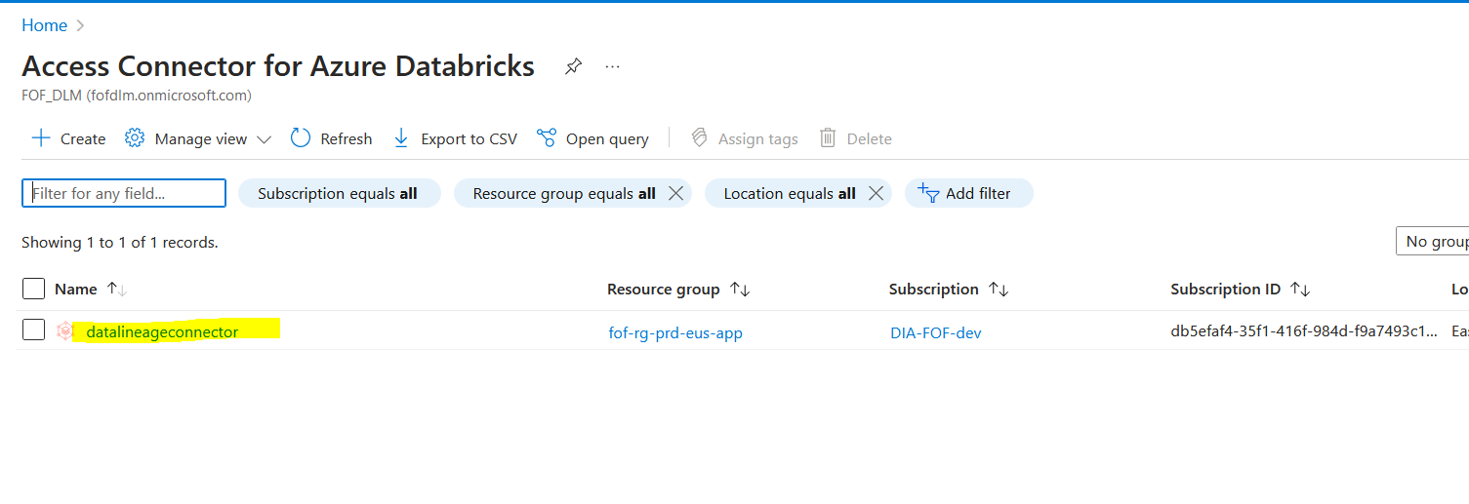

1.9 Click on overview -> copy resource ID and save it for further usage

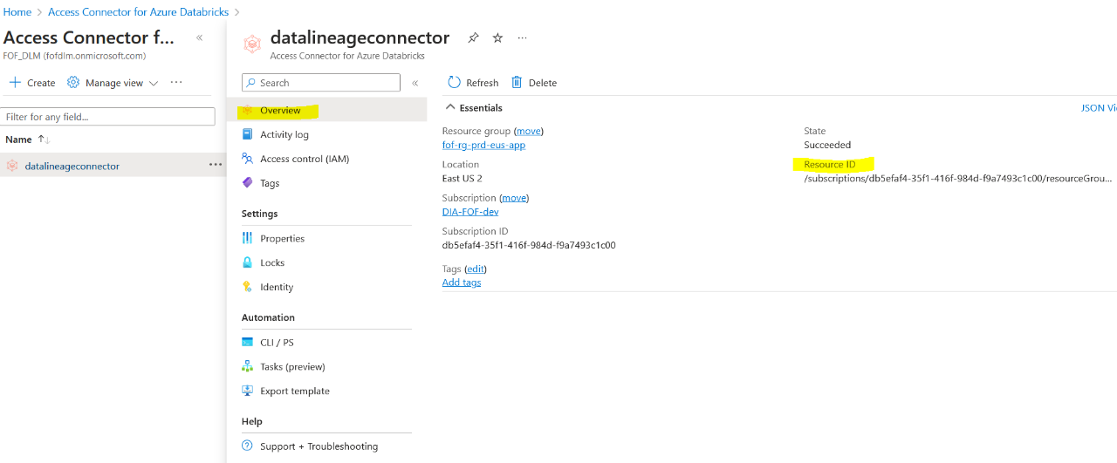

1.10 Go back to home page -> select Azure Databricks Service(**fof-dbr-prd-eus-wsp**)

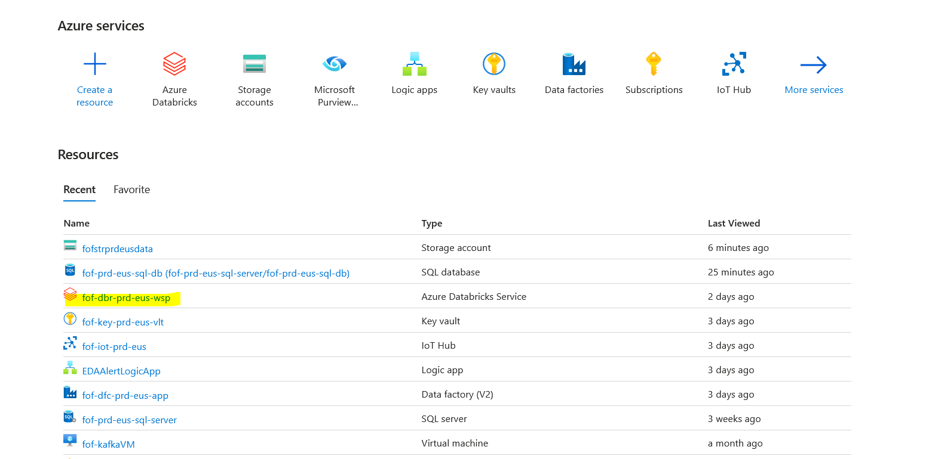

1.11 Click on Launch workspace

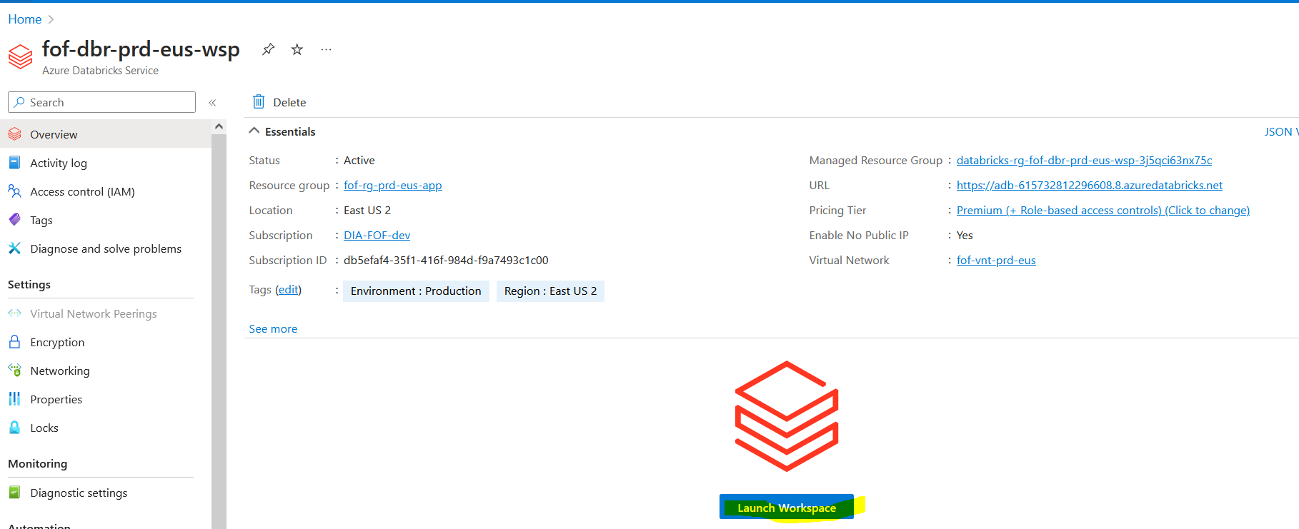

1.12 Go to manage account

Note : Need Admin Role to access Manage Account

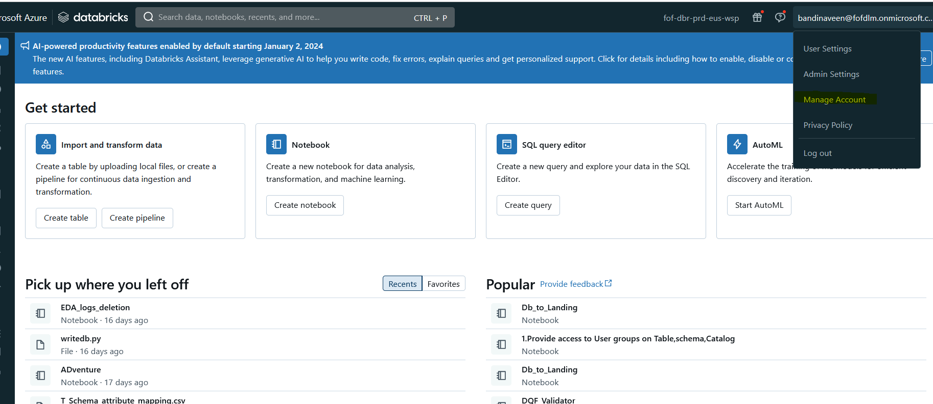

1.13 Click on create metastore -> create metastore

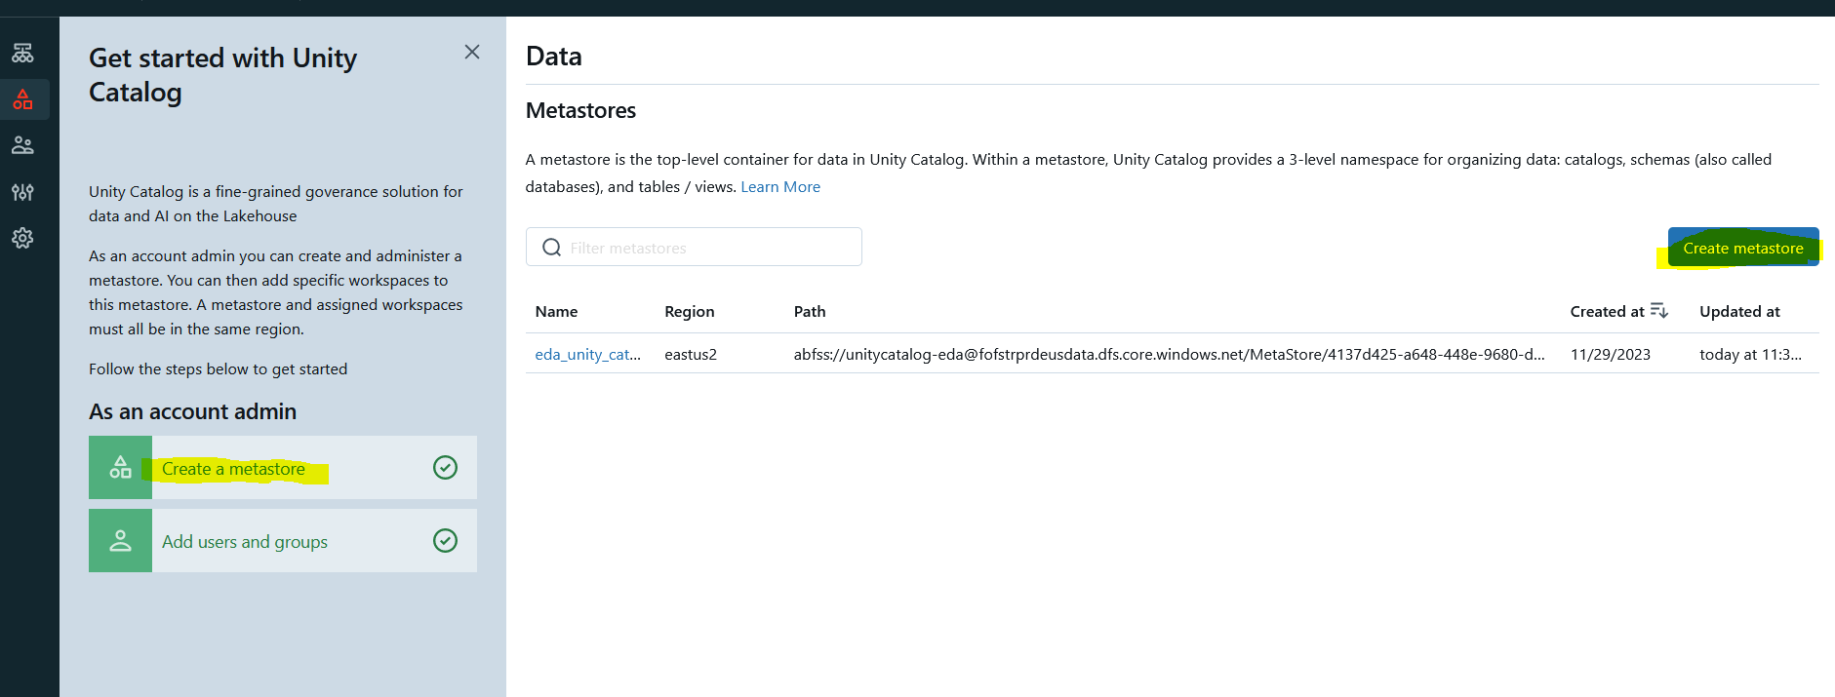

1.14 Fill the required details and click on create.

Note : Region need to be same as Azure Databricks region

Access Connector ID is same as Resource ID (from step 1.9)

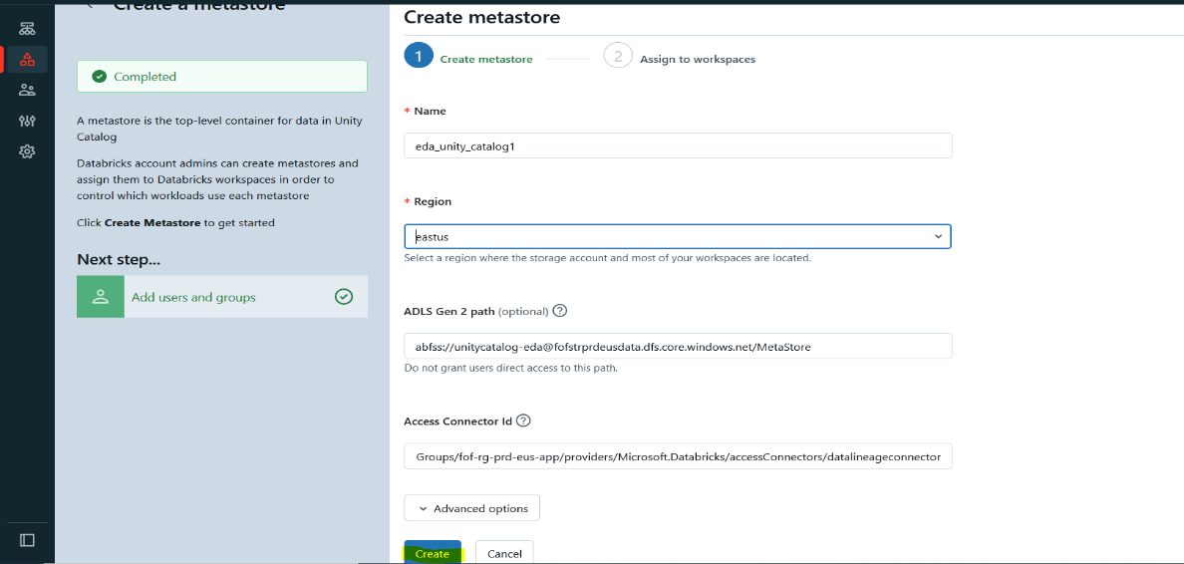

1.15 Select databricks workspace and click on assign

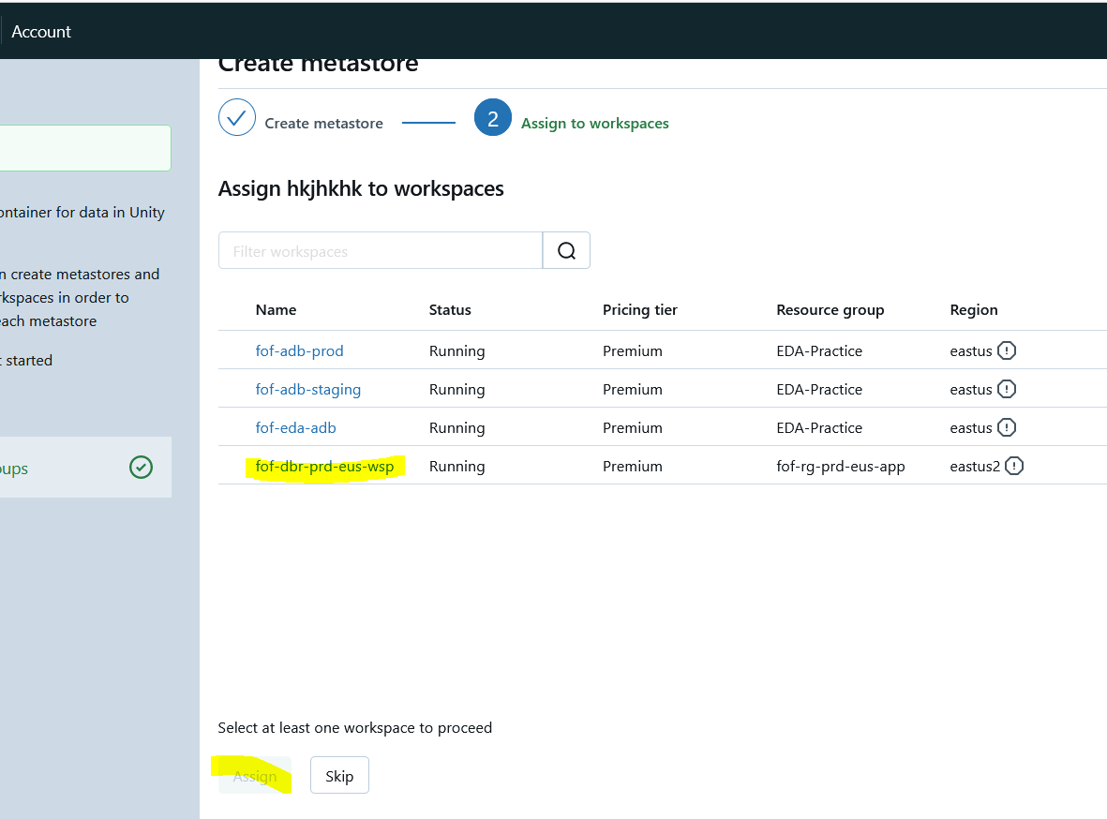

1.16 To check the created metastore click on Data -> eda_unity_catalog

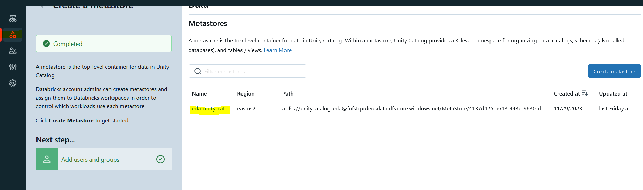

1. Creation of Interactive Cluster:

**Note**: In our setup, we employ single-node cluster for file validation and multinode single-user cluster for DQF validation.

2.1 Creation of Single node Interactive Cluster:

2.1.1 On left side of the Databricks menu list, click on the compute for the creation of

single node cluster.

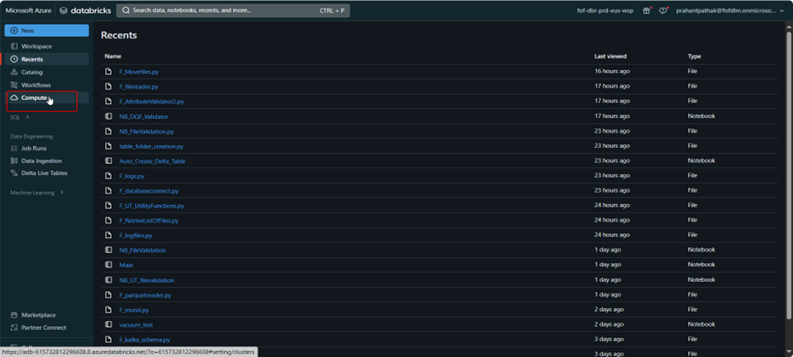

2.1.2 Go to, Compute -> Create Cluster.

Click on Create compute

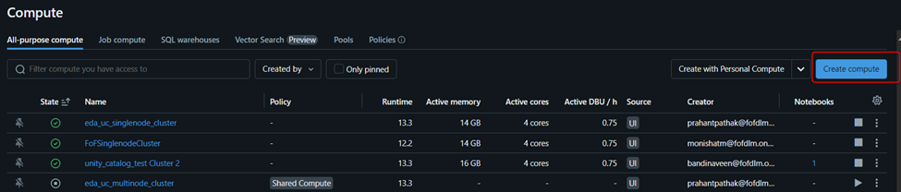

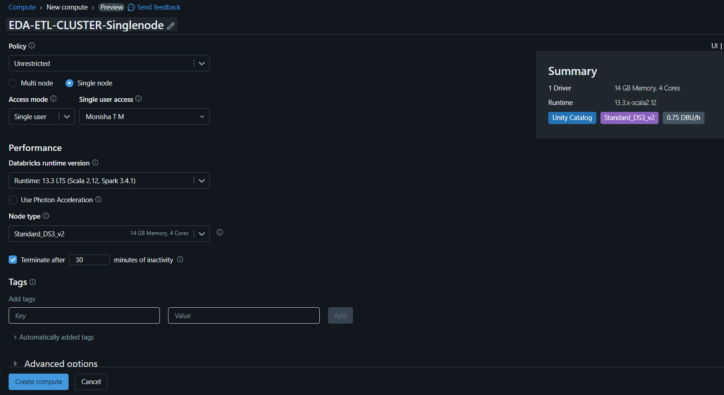

Enter the details and configurations of the Clusters.

* Name - <projectname>-ETL-CLUSTER-Singlenode
* Access mode – Single user ( by default)
* Node Type – Standard_DS3_v2

**Note**: Access mode no isolation shared will not enable unity catalog

In Advanced option add below line :

spark.driver.memory 6g

spark.master local[*, 4]

spark.driver.defaultJavaOptions -XX:+G1HeapRegionSize

spark.databricks.cluster.profile singleNode

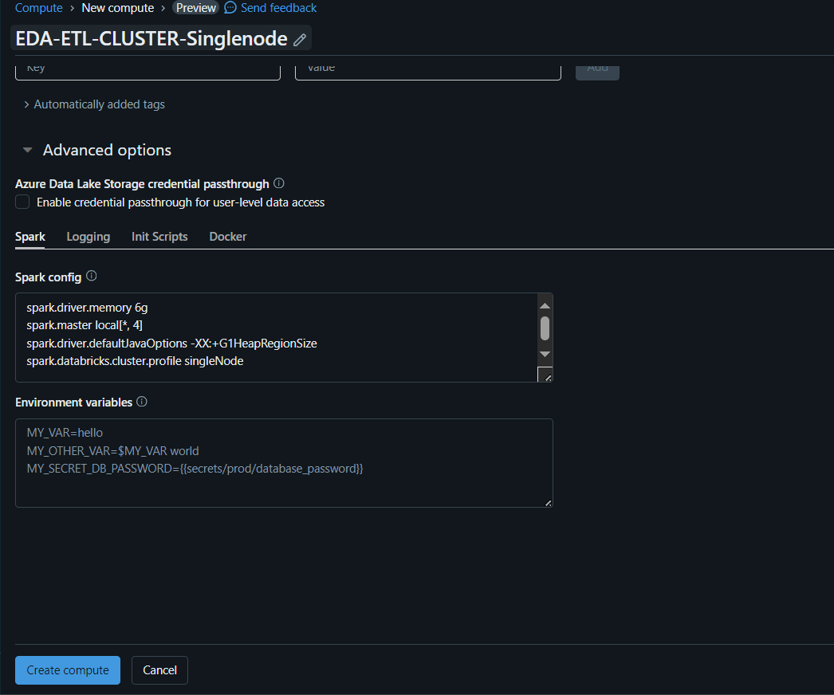

2.1.3 After the creation of cluster, click on the cluster and go to libraries tab.

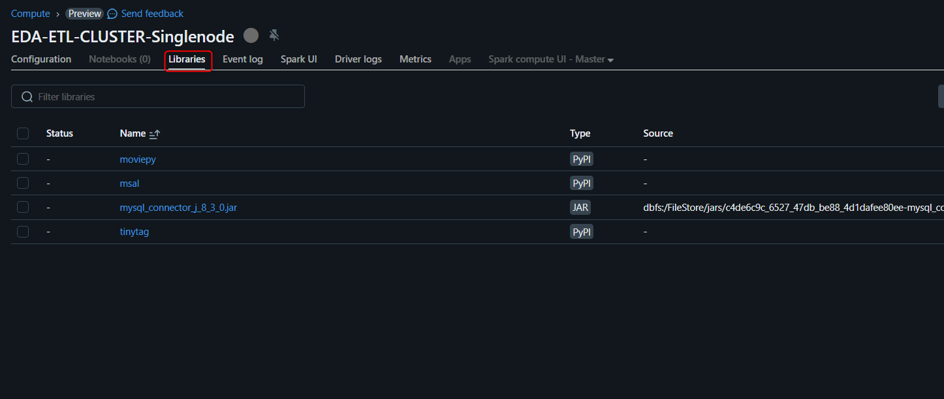

2.1.4 Click on libraries after creation of cluster.

Click on Install new.

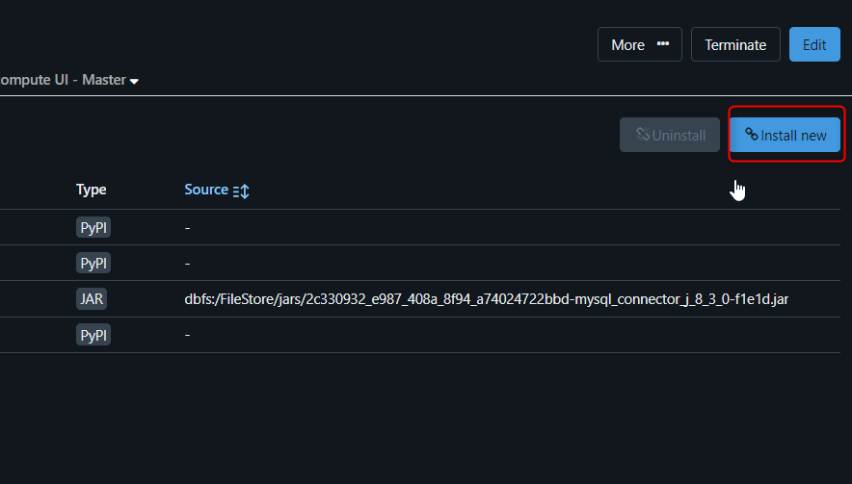

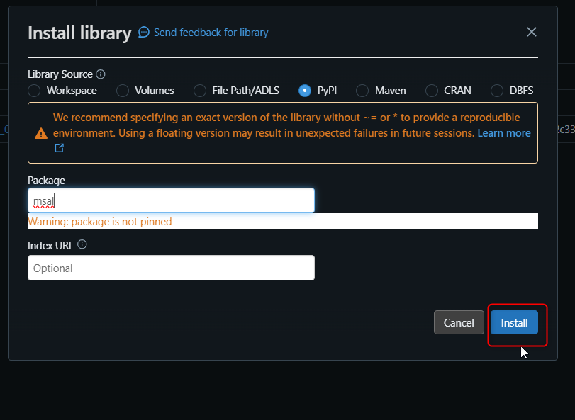

Click on install new -> Select PyPI as Library Source.

Enter msal as the package name -> Install.

Now, the msal library has been installed in the cluster.

Follow above steps for installation of libraries to install the remaining libraries that are listed below.

|  |  |  |
| --- | --- | --- |
| Libraries | Latest Version | Source |
| DBUtils | 3.0.3 | PyPI |
| Tinytag | 1.9.0 | PyPI |
| moviepy | 1.0.3 | PyPI |

ADF Pipeline changes

2.1.5 Open Azure Data Factory and go to manage section:

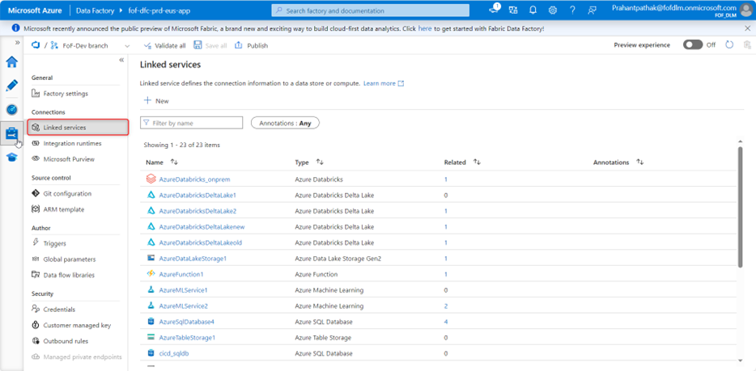

2.1.6 Go to Linked services -> Click on + New.

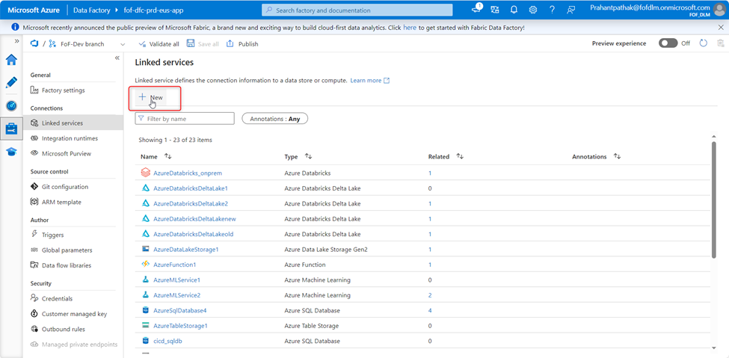

2.1.7 Go to Compute and select Azure Databricks.

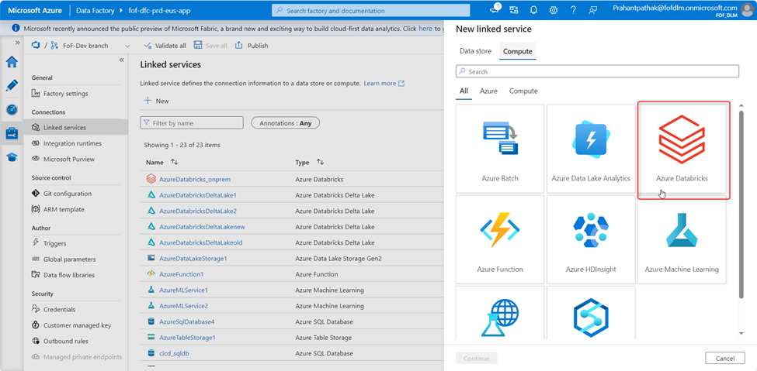

2.1.8 Provide details as shown below and select cluster as existing interactive cluster.

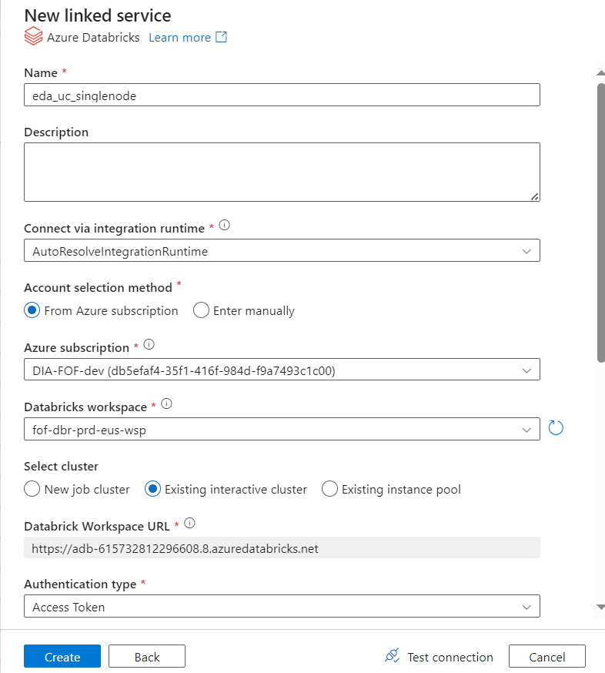

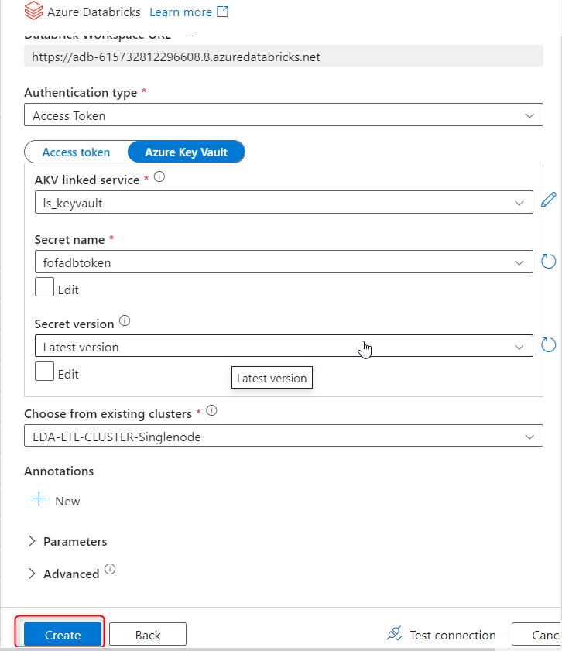

Then click on create button.

2.1.9 Then go to your pipeline which you want to run.

Click on Author -> Select pipeline pl_Landing_to_Bronze.

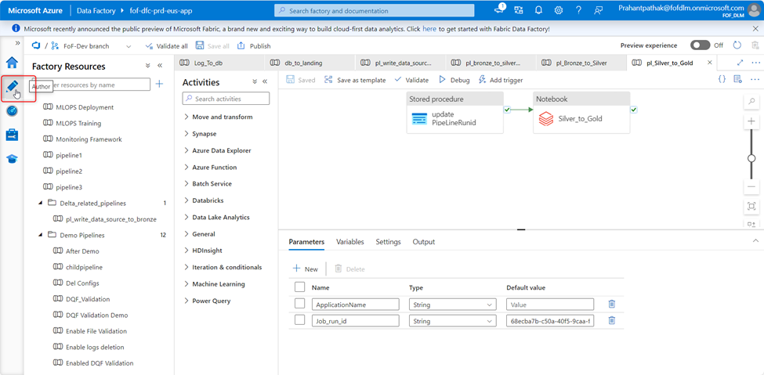

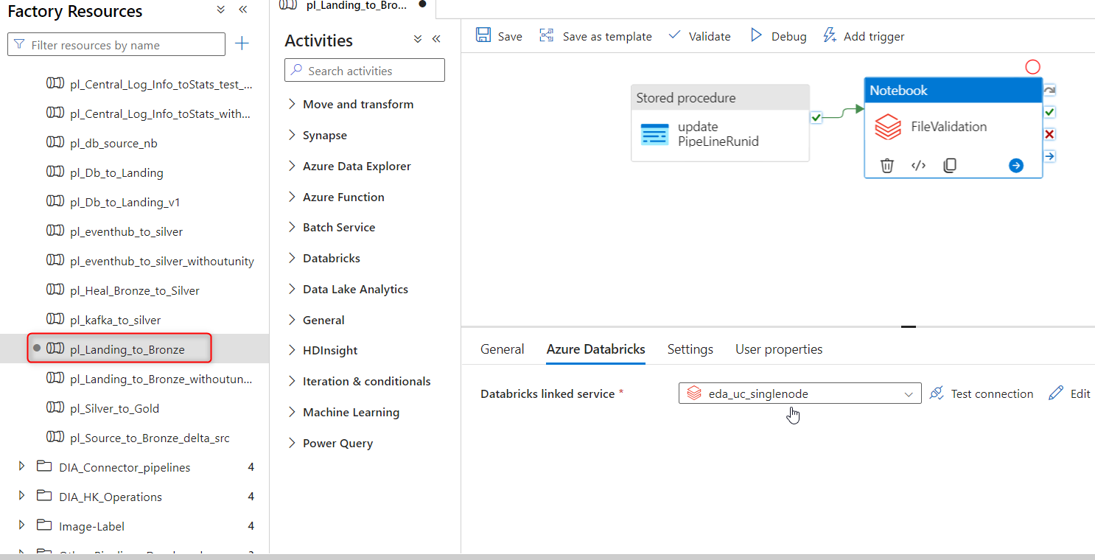

2.1.10 Click on Notebook activity ->Azure Databricks -> Select your linked service.

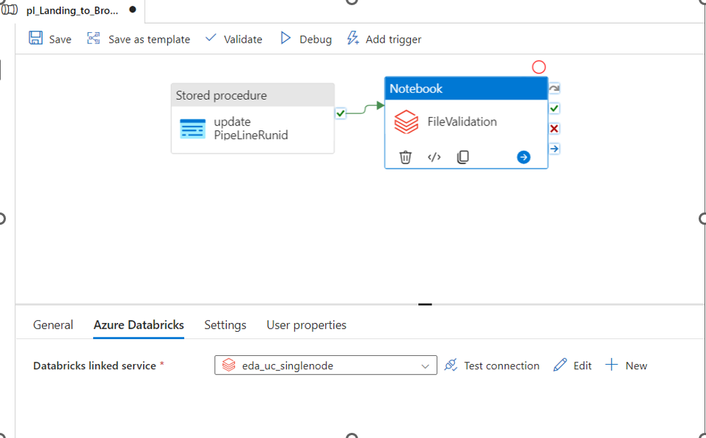

2.2 Creation of Multinode single user interactive cluster:

2.2.1 On left side of the Databricks menu list, click on compute for the creation of

Multinode single user cluster.



2.2.2 Go to, Compute -> Create Cluster.

Click on Create compute



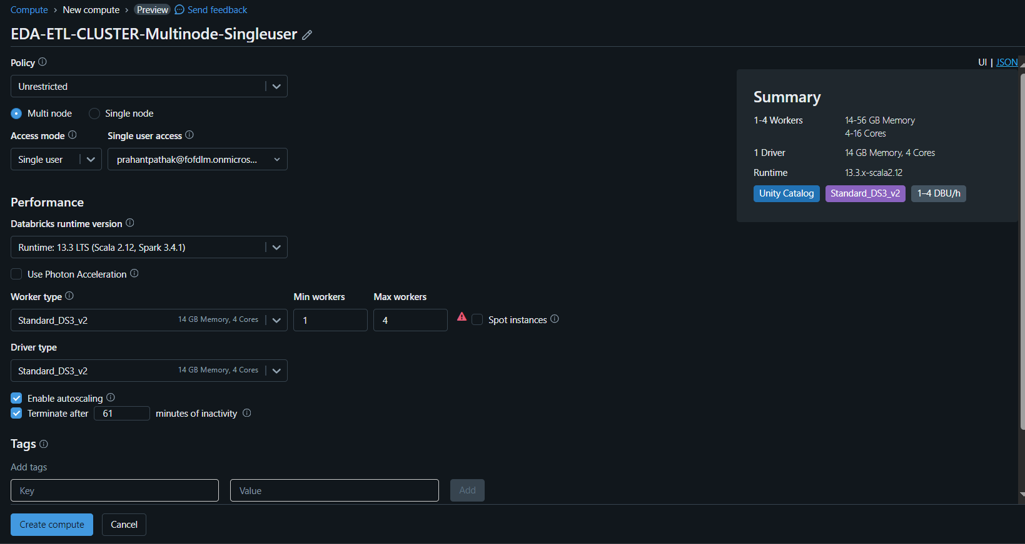

Enter the details and configurations of the Clusters.

* Name - <projectname>-ETL-CLUSTER-Multinode_Singleuser
* Access mode – Single user
* SKU – Standard_DS3_v2 (worker type)
* Standard_DS3_v2(Driver type)

**Note**: Access mode no isolation shared will not enable unity catalog

In Advanced option add below line :

spark.hadoop.fs.azure.account.key.<STORAGEACCOUNTNAME> <ACCESS_KEY>

Note: - Access key of storage account

spark.executor.defaultJavaOptions -XX:+G1HeapRegionSize

spark.driver.defaultJavaOptions -XX:+G1HeapRegionSize

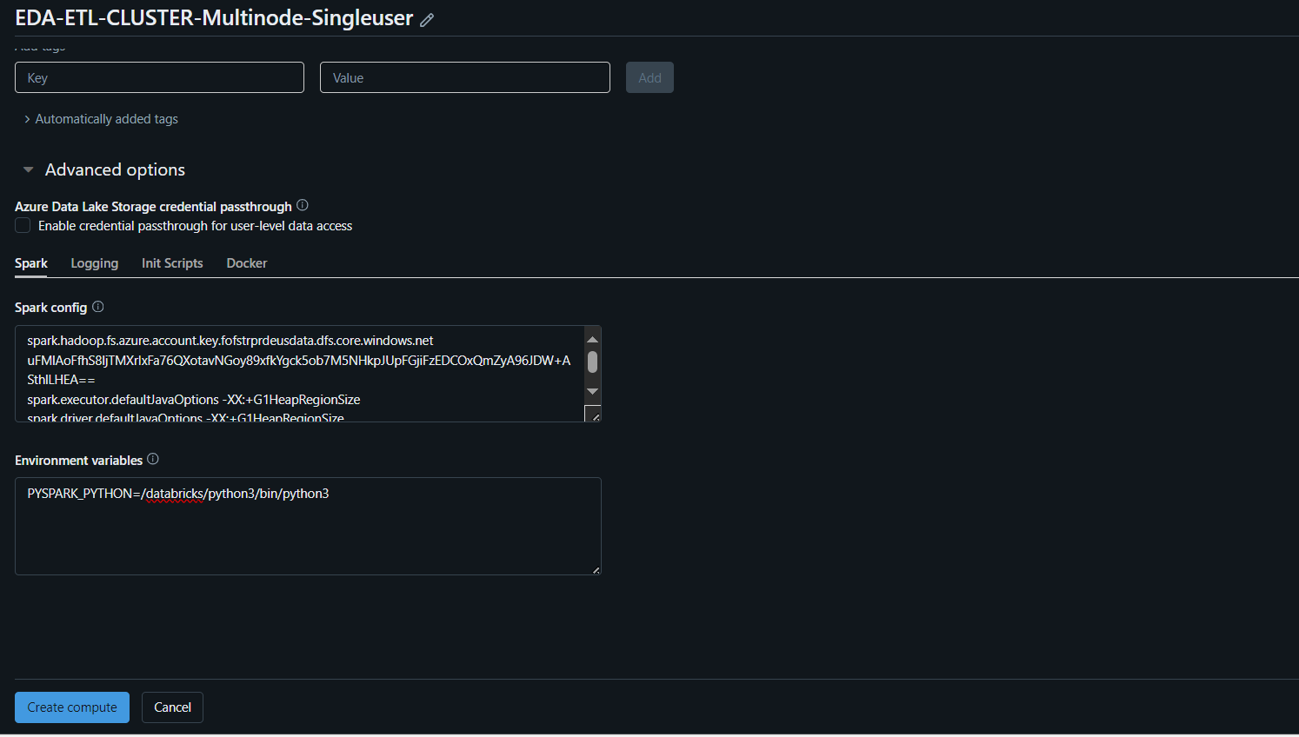

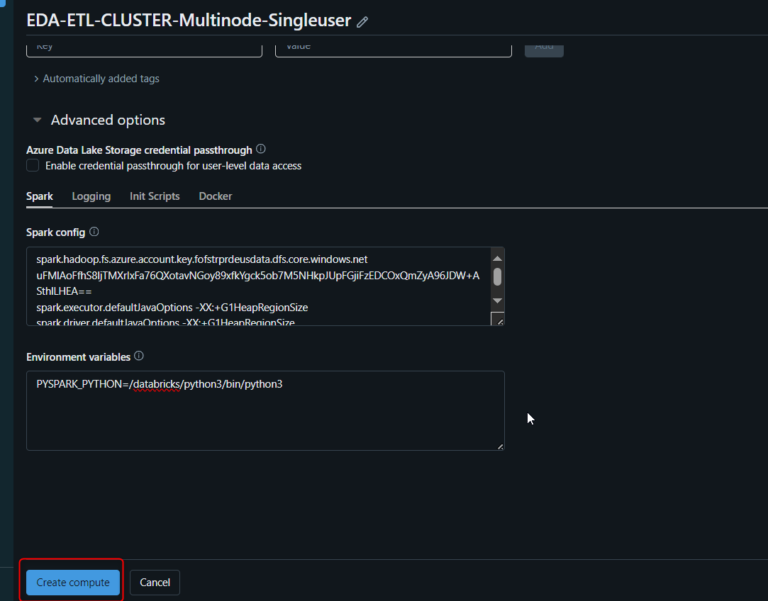

2.2.3 After the creation of cluster, click on the cluster and go to libraries tab.

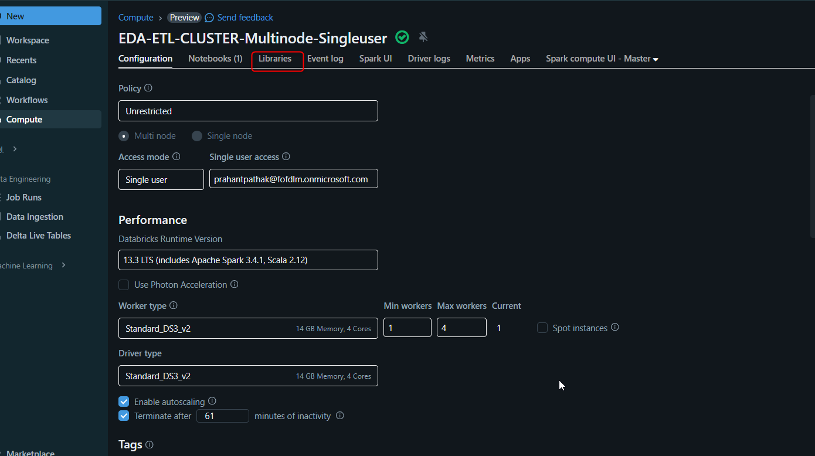

2.2.4 Click on libraries after creation of cluster.

Click on Install new.





Click on install new -> Select PyPI as Library Source.

Enter msal as the package name -> Install.

Now, the msal library has been installed in the cluster.

Follow above steps for installation of libraries to install the remaining libraries that are listed below.

|  |  |  |
| --- | --- | --- |
| Libraries | Latest Version | Source |
| DBUtils | 3.0.3 | PyPI |
| Faker | 19.2.0 | PyPI |
| Tinytag | 1.9.0 | PyPI |
| moviepy | 1.0.3 | PyPI |

ADF Pipeline changes

2.2.5 Open Azure Data Factory and go to manage section:



2.2.6 Go to Linked services -> Click on + New.



2.2.7 Go to Compute and select Azure Databricks.



2.2.8 Provide details as shown below and select cluster as existing interactive cluster.

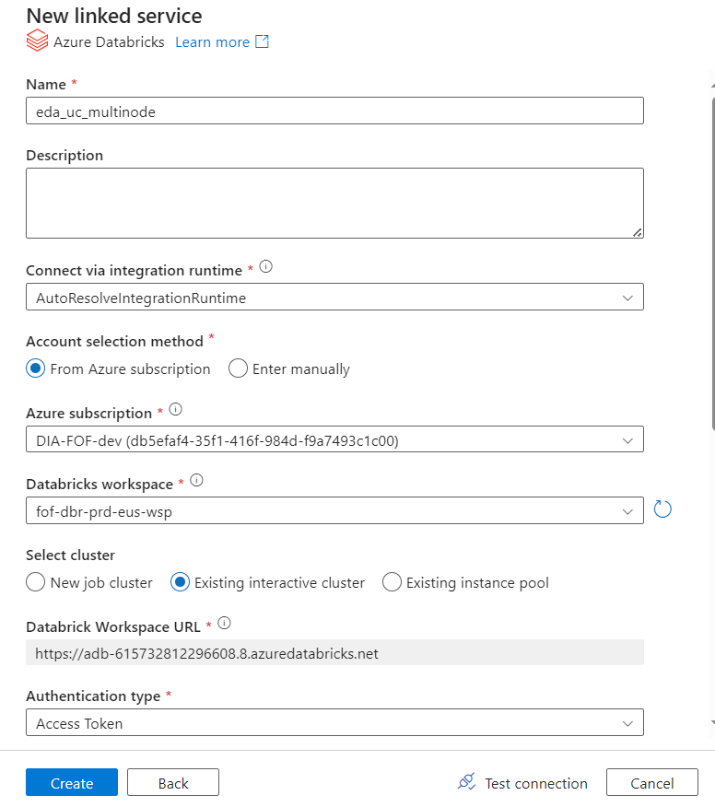

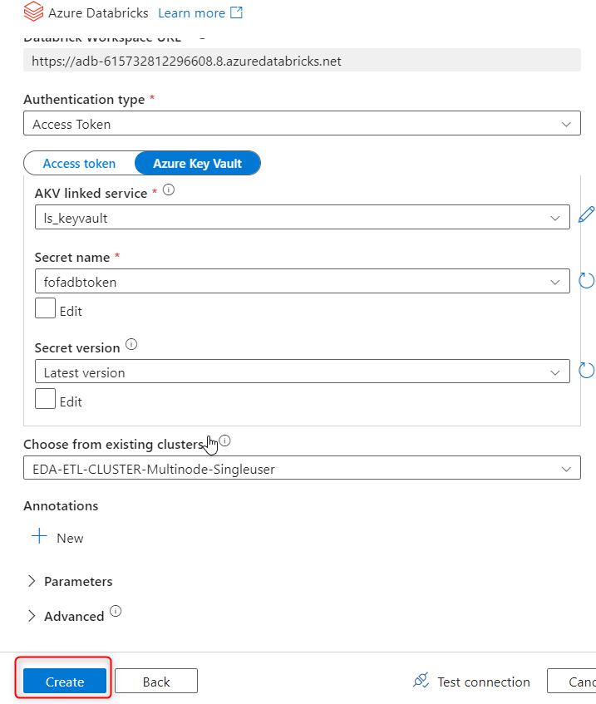

Then click on create button.

2.2.9 Then go to your pipeline which you want to run.

Click on Author -> Select pipeline pl_Bronze_to_Silver.



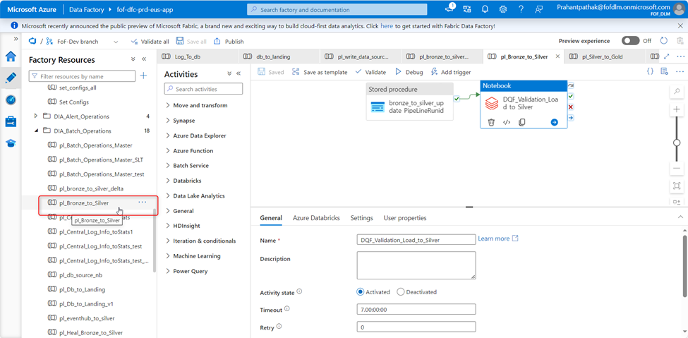

2.2.10 Click on Notebook activity ->Azure Databricks -> Select your linked service.

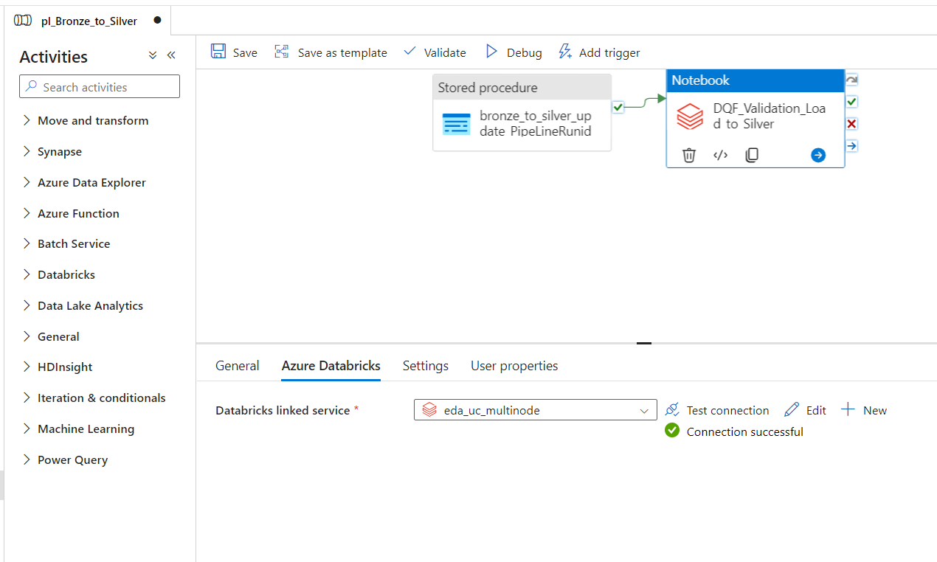

3. Creation of Catalog:

Prerequisite:

The owner of the storage credentials must grant permission to the user intending to create an external location using these credentials.

3.1 Creation of catalog using python script:

3.1.1 Creation of **catalog** folder for each layers in container for defining path in external location.

For bronze layer it is shown below:

Click on + container and create a container for bronze and create a catalog folder inside it.

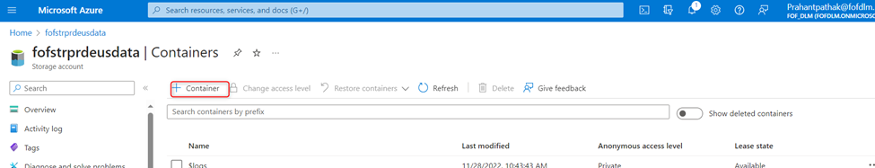

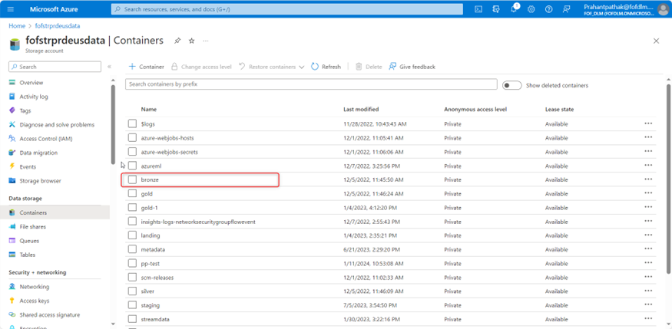

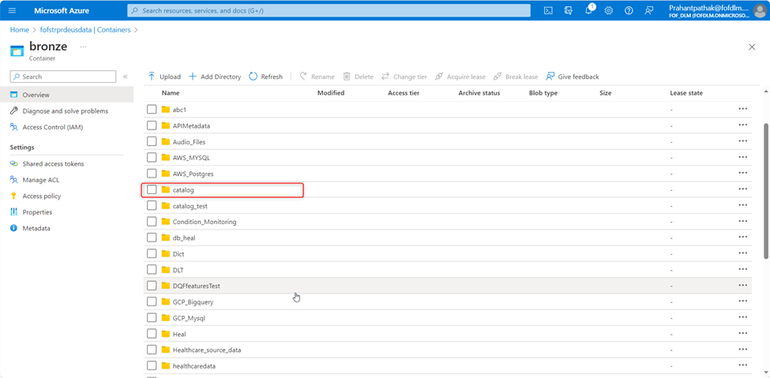

3.1.2 Creation of storage credentials for external location to refer :

Login to databricks workspace and go to catalog explorer and select storage credentials then click on create credential.

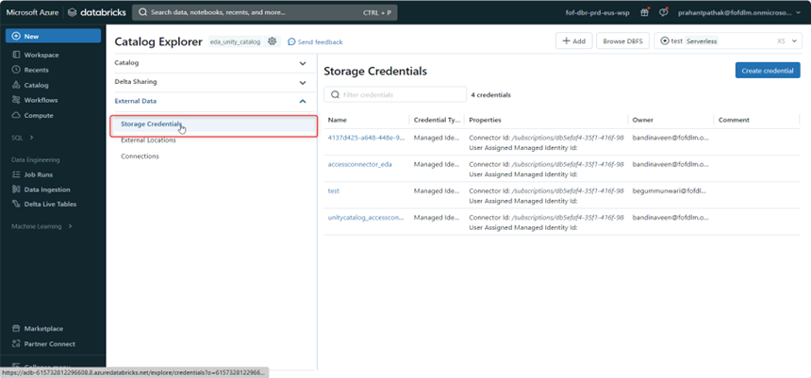

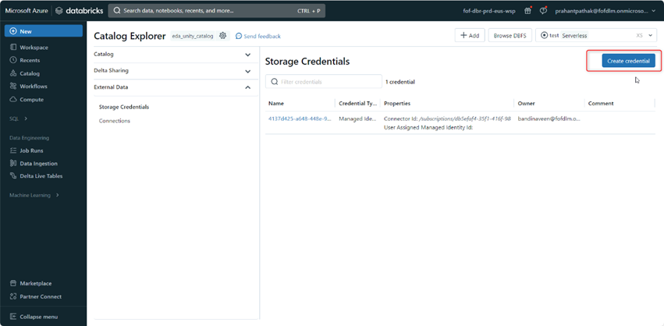

For access connector ID, go to access connector resource and click on properties and copy its id as shown below.

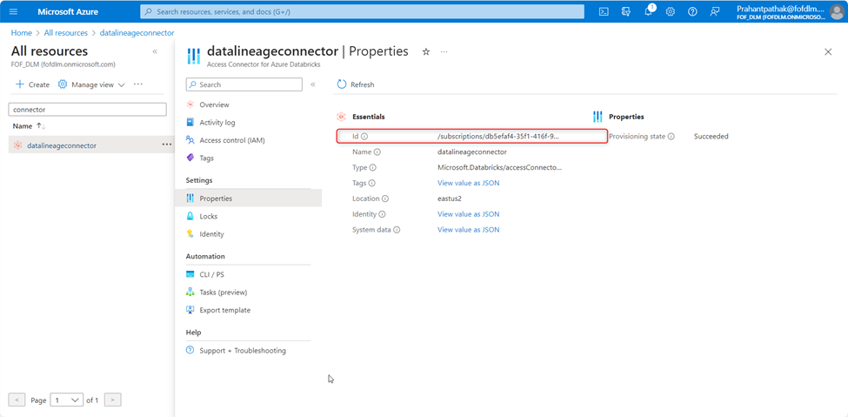

Provide details as mentioned in screenshot and click on create.

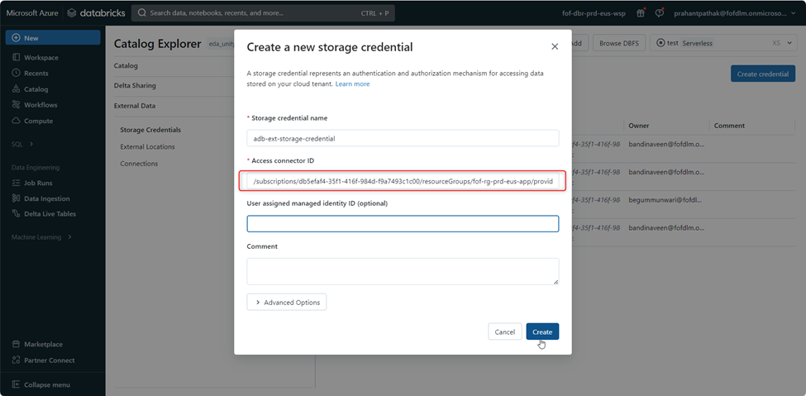

3.1.3 Create external locations for each layer of catalog to refer it as managed location by using script.

Refer this notebook by using this link provided below:

[Catalogs creation - Databricks (azuredatabricks.net)](https://adb-615732812296608.8.azuredatabricks.net/?o=615732812296608#notebook/1568859544150480/command/1568859544150490)

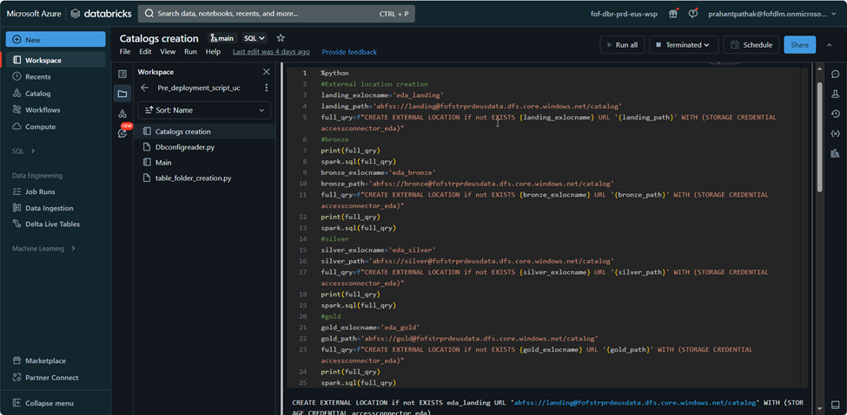

3.1.4 Creation of catalogs for each layer.

Refer this notebook by using this link provided below:

[Catalogs creation - Databricks (azuredatabricks.net)](https://adb-615732812296608.8.azuredatabricks.net/?o=615732812296608#notebook/1568859544150480/command/1568859544150491)

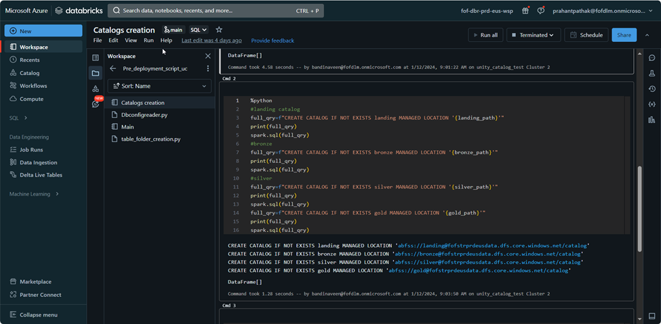

Note : Access to various catalogs can be granted based on user groups, and further details on this process are elaborated in the subsequent "Providing Access to User Group" section.

3.2 Manual steps in case of difficulty with the script :

**Note:** The steps outlined below are intended for the manual creation of the catalog. As part of the pre-deployment script, these actions have been executed using a Python script, which is provided before the manual creation step.

3.2.1 Creation of directory for each layers in container for defining path in external location.

For bronze layer it is shown below:

Click on + container and create a container for bronze and create a catalog folder inside it.







3.2.2 Creation of storage credentials for external location to refer :

Login to databricks workspace and go to catalog explorer and select storage credentials then click on create credential.





3.2.3 For access connector ID, go to access connector resource and click on properties and copy its id as shown below.



3.2.4 Provide details as mentioned in screenshot and click on create.



3.2.5 Create external locations for each layer of catalog to refer it as managed location:

Go to catalog explorer and click on External Locations and then create location.

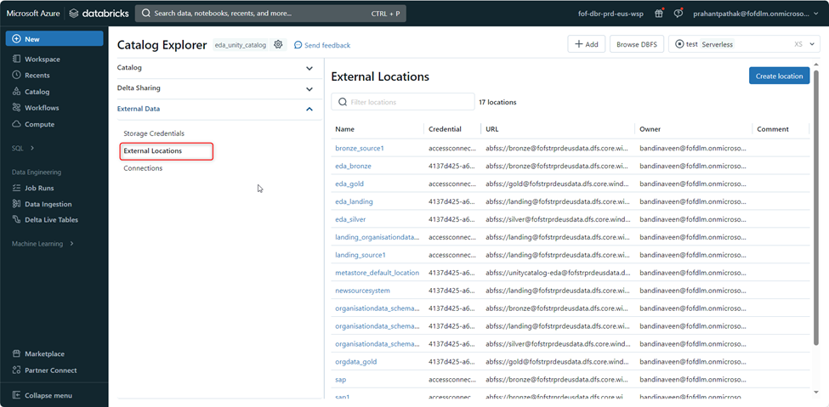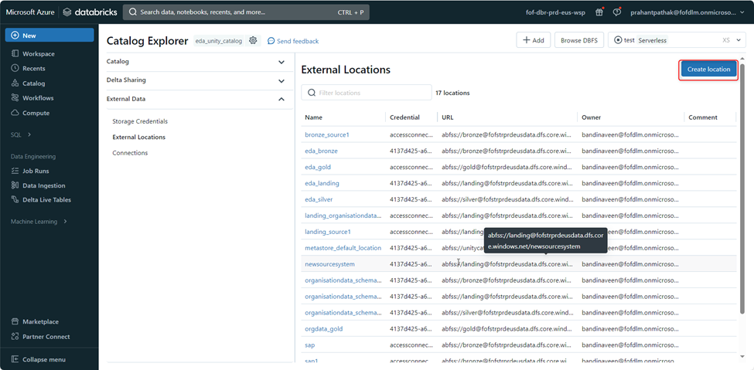

3.2.6 Select storage credential which you have created earlier from the drop down menu and URL as per directory which we have created earlier for our bronze layer(Similarly we need to proceed ahead for other layers also).

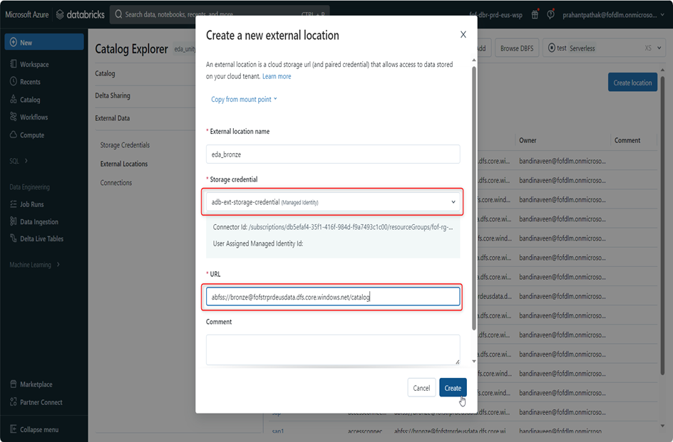

3.2.7 Create catalog for each layer.

Go to catalog explorer then click on catalog and create catalog.

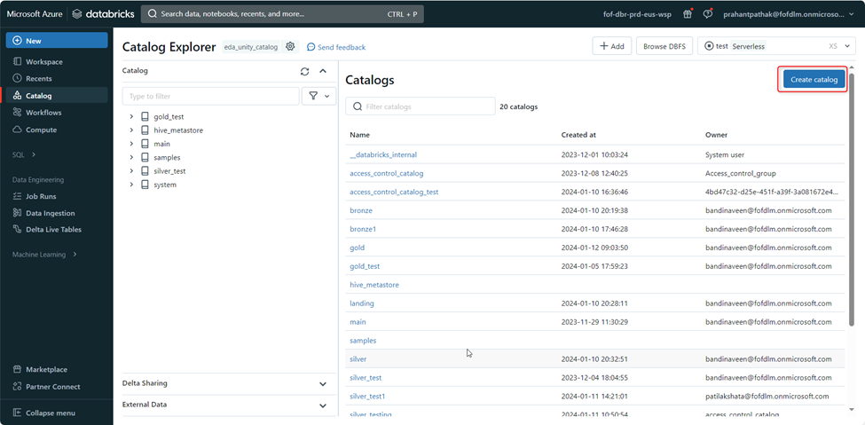

Select respective storage location which you have created for each layer in last step and then click on create button.

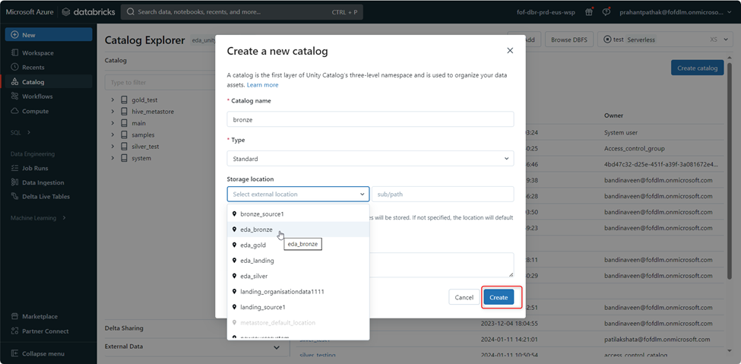

3.2.8 Grant all privileges to the catalog for the Access_control_group

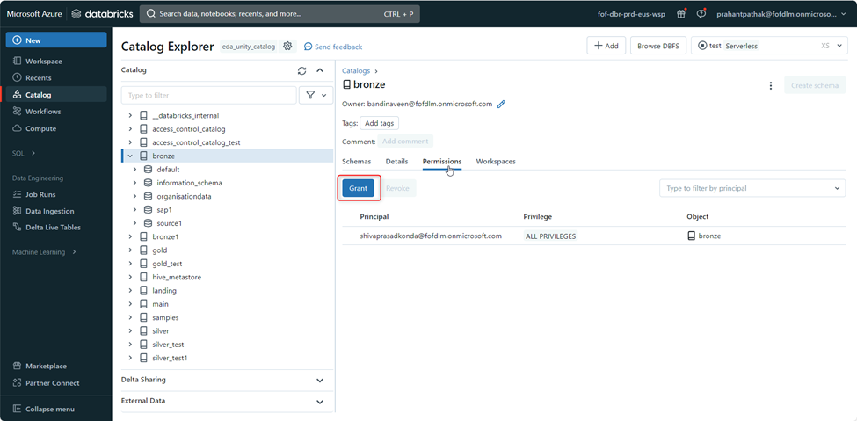

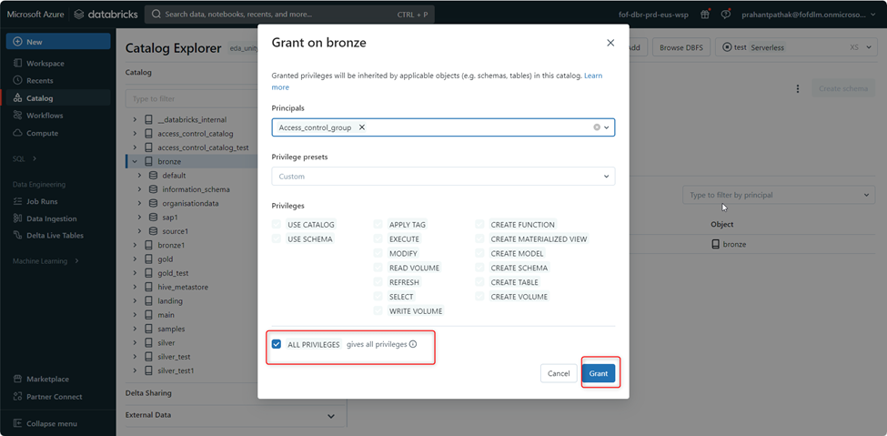

4. Creation of Schemas Based on Source System:

Pre-requisite: Notebook: </Repos/bandinaveen@fofdlm.onmicrosoft.com/logs/Pre_deployment_script_uc/Main> should run as the part of pre-deployment scripts, after running the notebook it will create Catalog, Schema, Table and Volume.

After the Catalog,Schema and Table is created, permission would be required in order to read the data or edit data.

The notebook located at /Repos/bandinaveen@fofdlm.onmicrosoft.com/logs/Pre_deployment_script_uc/Main serves the purpose of creating schemas, volumes, and tables based on a unique identifier known as FNT_ID. This FNT_ID is associated with each new source added to Azure SQL.

Below is the functionality of the code present in the notebook:

1. **Widget Usage for FNT_ID and Storage Account:**

Widgets are employed to facilitate the input of FNT_ID and storage_account values. Users can input specific FNT_IDs for different sources. For example, in the provided sample, FNT_ID is set to 260, and the storage_account is set to "fofstrprdeusdata".

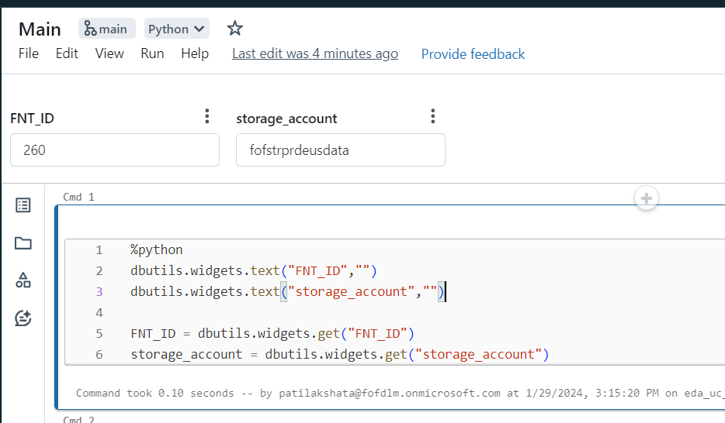

2. **Code Block Imports and Functionality.**

The code block includes import statements for three modules:

* **Dbconfigreader**: This module is responsible for importing configurations specific to a given FNT_ID from the Azure SQL database.
* **commonfunc.databaseconnect**: This module aids in establishing a connection to the database.
* **table_folder_creation**: This module is utilized for the creation of delta tables and folders.

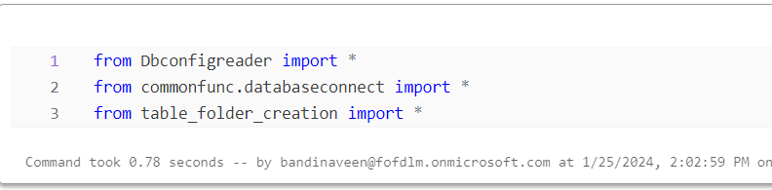

3**.Storage Account Key Extraction:**

The code segment storage_account_key = dbutils.secrets.get(scope="fof-prd-scope", key="storage-account-key") is employed to retrieve the storage account key from a secure storage, such as Azure Key Vault. The dbutils.secrets.get function is utilized to extract and store the storage account key in the variable storage_account_key.

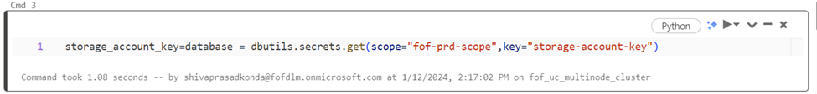

4. **Below is the working of the above block of code**:

**Set Spark Configuration:**

spark.conf.set("spark.sql.legacy.timeParserPolicy", "LEGACY"): This sets a Spark configuration to use the legacy time parser policy.

**Retrieve SQL Server Connection Details:**

* server = dbutils.secrets.get(scope="fof-prd-scope", key="sqlSever"): Retrieves the SQL Server hostname from Databricks secrets.
* database = dbutils.secrets.get(scope="fof-prd-scope", key="sqlDB"): Retrieves the SQL Server database name from Databricks secrets.

**Create Spark Session:**

* spark1 = SparkSession.builder.appName('integrity-tests').getOrCreate(): Creates a Spark session with the specified application name.

**Define Data Lake Layers:**

* source_dl_layer = 'Bronze': Specifies the source data lake layer as 'Bronze'.
* dest_dl_layer = 'Silver': Specifies the destination data lake layer as 'Silver'.

**Database Connection and Configuration:**

* dbasecon = DBconnection(database=database, server=server, spark1=spark1): Creates an instance of the DBconnection class with specified parameters.
* con = dbasecon.fn_get_connection(): Obtains a database connection using the fn_get_connection method.

**Configuration Reader:**

* configreader = Dbconfigreaders(con, FNT_ID): Creates an instance of the Dbconfigreaders class with a database connection and FNT_ID.
* config_dict = configreader.getall_configs(): Retrieves configuration information as a dictionary using the getall_configs method.

**Extract Information from Configuration:**

* Extracts relevant information such as **schema1**, **Sourcesystem**, **FileTemplate**, and **dbname** from the configuration dictionary.

**Print Extracted Information:**

* Prints the extracted information to the console.

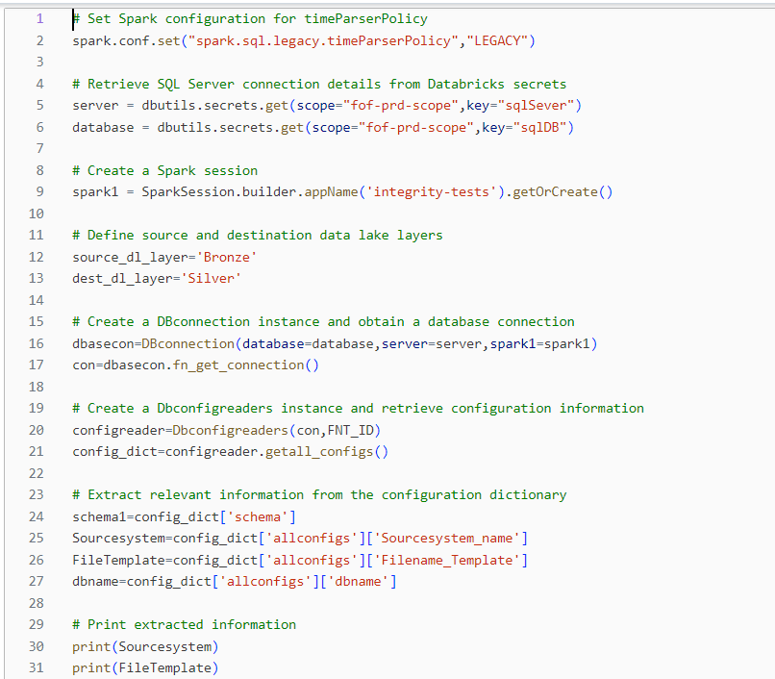

5**. Dynamic Path Generation for Data Storage Layers.**

The provided code dynamically constructs file system paths for various data storage layers, including landing, bronze, and silver, using the Azure Databricks ABFS syntax. These paths are tailored for specific **Sourcesystem** identifiers and organized within Azure Storage containers. The landing schema accommodates incoming data, while the bronze and silver schemas represent raw and processed stages, respectively.

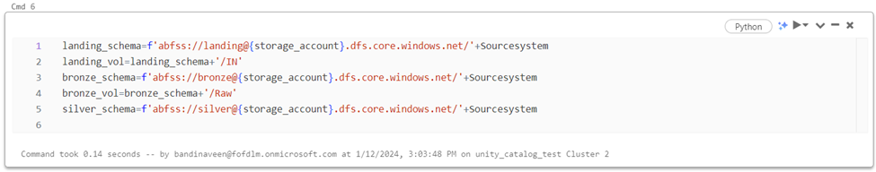

6.**Create folder if it does not exists.**

**Setting Storage Account Key:**

* spark.conf.set(f"fs.azure.account.key.{storage_account}. dfs.core.windows.net", storage_account_key): Configures the Azure Storage account key for the specified storage_account to enable access to the associated DBFS.
* Checking and Creating Schemas: The code uses dbutils.fs.ls to check if the specified schemas (landing_schema, bronze_schema, and silver_schema) exist in the DBFS. If they do not exist, it catches the exception and creates the schema using dbutils.fs.mkdirs. For each schema, a corresponding print statement indicates whether the schema already exists or has been newly created.

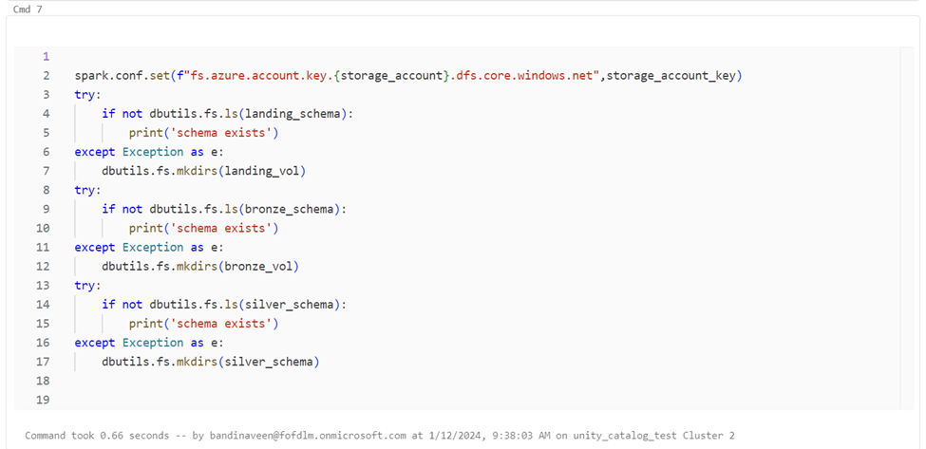

7. **Dynamic External Location Creation for landing, bronze and silver layer.**

* The provided code dynamically creates external locations in Azure Databricks for landing, bronze, and silver data storage layers, with each external location tailored to a specific Sourcesystem.
* The external locations leverage Azure Blob File System (ABFS) paths and are associated with a storage credential named 'accessconnector_eda'.
* The code generates SQL queries for each external location, specifying the ABFS URL and storage credential, ensuring an adaptive and organized setup for different data layers within the Azure Storage account.
* The SQL queries are then executed using Databricks' spark.sql function, allowing for efficient and flexible external location creation based on the unique identifier of each data source.

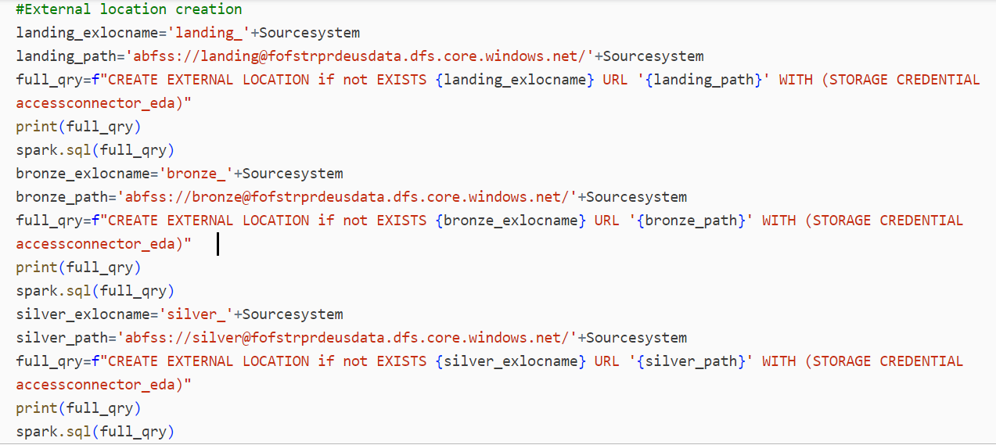

8. **Schema and Volume Creation for Landing, Bronze, and Silver Data Layers**

In this code snippet, dynamic schemas and external volumes are created in Azure Databricks for landing, bronze, and silver data layers based on a specified Sourcesystem. The landing schema and volume are managed, with the schema located at the specified 'landing_path' and the volume including a subdirectory 'IN'. Similarly, the bronze schema and volume are created, with the 'Raw' subdirectory in the volume. The silver schema is managed, located at the 'silver_path'. SQL queries are generated for each creation step and executed using spark.sql.

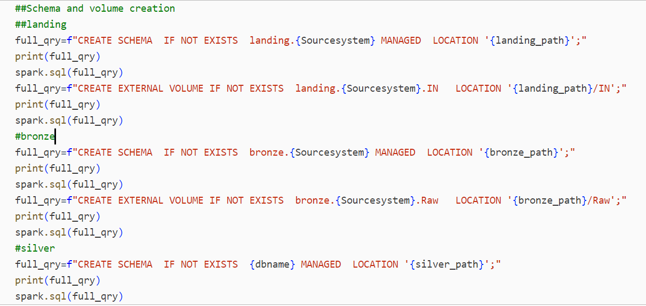

9**.Script for Delta Table creation with good and Bad Data.**

For this script we have Py. File in that there will be a function when we run the script the second delta table in the notebook will call the function then we get the good data and bad data.

The script is creating two Delta tables, one for storing successfully processed records example : (T_department_data) and another for storing data with errors example :(T_department_data_baddfdata).

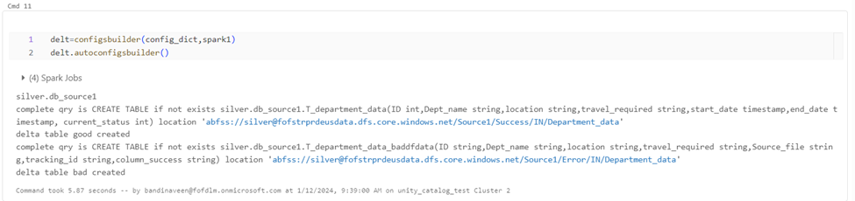

**Note** : we can run the notebook ([/Repos/bandinaveen@fofdlm.onmicrosoft.com/logs/Pre_deployment_script_uc/Main](mailto:/Repos/bandinaveen@fofdlm.onmicrosoft.com/logs/Pre_deployment_script_uc/Main)) either manually and passing the values through widgets or can be integrated in Azure Data Factory Pipeline to pick values dynamically.

5. Creation of User groups

Creation of user group must be done manually. To create a user group please follow the below steps

1. Once you are logged in to databricks workspace, click on user settings.

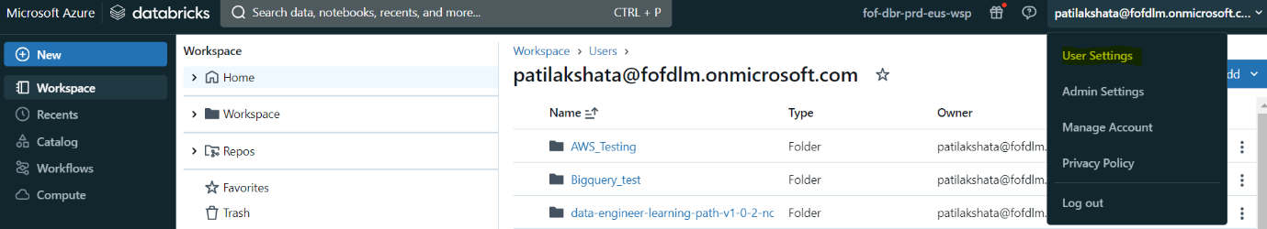

2. Click on Identity and Access.

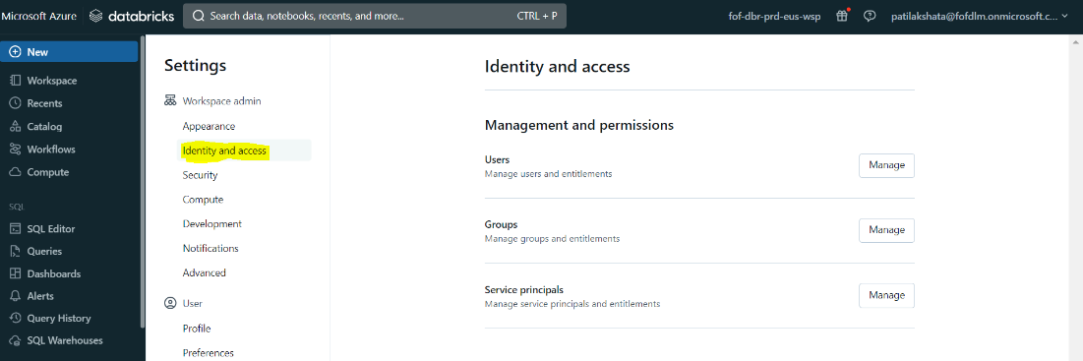

3. Click on Manage under groups

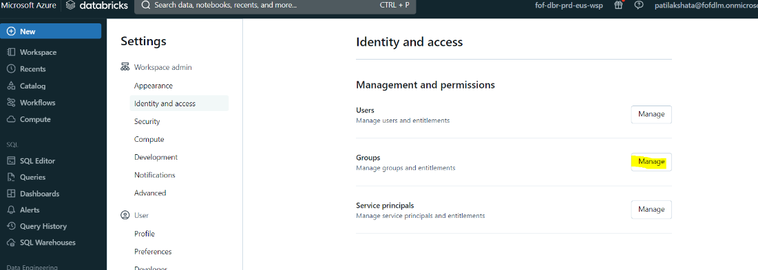

4. Click on Add group

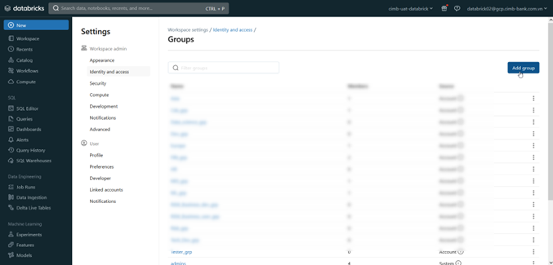

5. Click on Add new

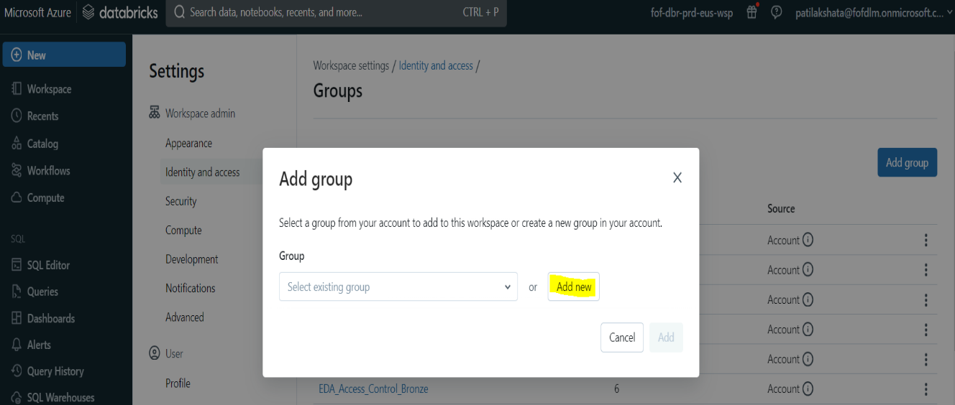

6.Enter the name of the group. Follow the naming convention mentioned below

<name of the group>_grp

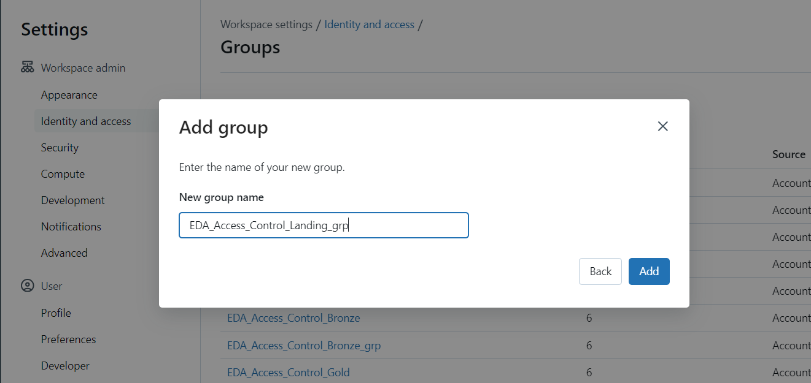

7. Click on Add

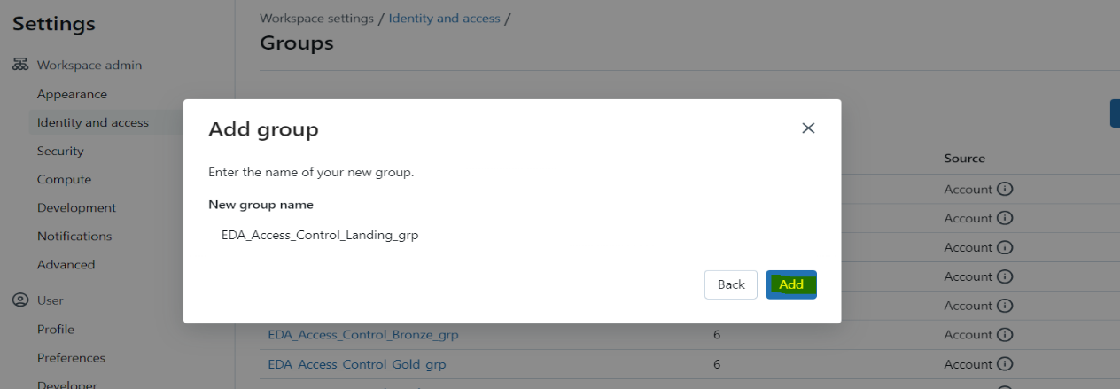

8.The group is created now. Verify the same by searching the group name.The group should appear as search result.

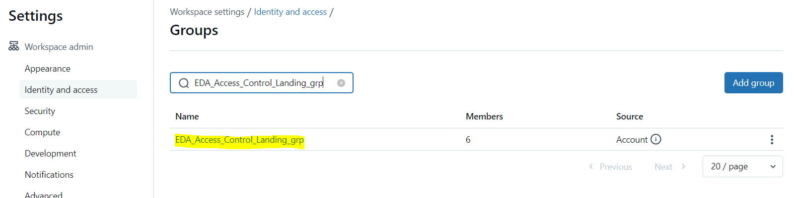

6. Add User to Users groups:

Pre-requisite:

To add any user to a user group,

1.Please ensure that the user already exists.

2. The user group already exists. If not, please follow steps in Creation of User groups:

Addition of user-to-user group must be done as below

1.Once you are logged in to databricks workspace, click on user settings:



2.Click on Identity and Access



3. Click on Manage under groups



4. Search for the group that you want to add user to.



5. select the group by clicking on it.Once the “group details” page opens, click on “Add members”.

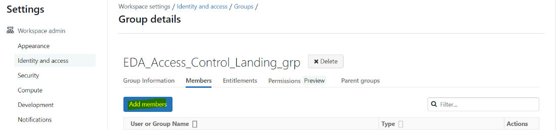

6.In the search box, type the name of the user that you want to add to this group. If the username is valid, it will appear as a search result.

Select the user.

You can add multiple users at the same time to a group.

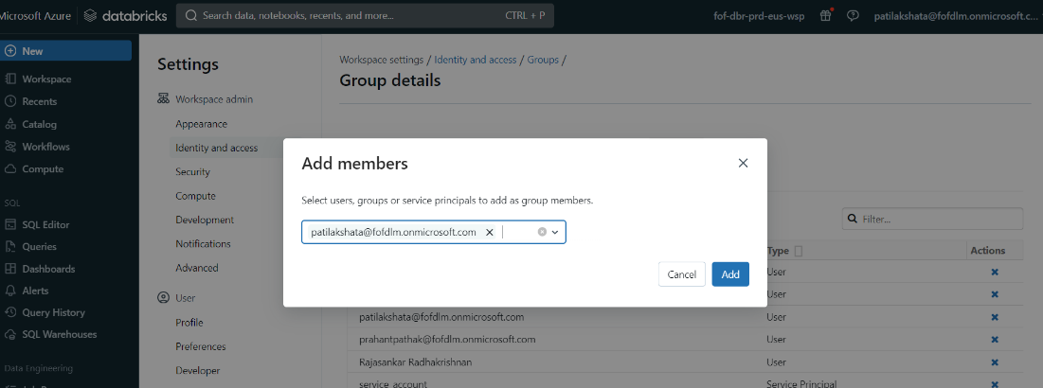

7.Once the users are selected, click on Add.

Once successfully added, under the members tab of the “group details” page the added users will appear.

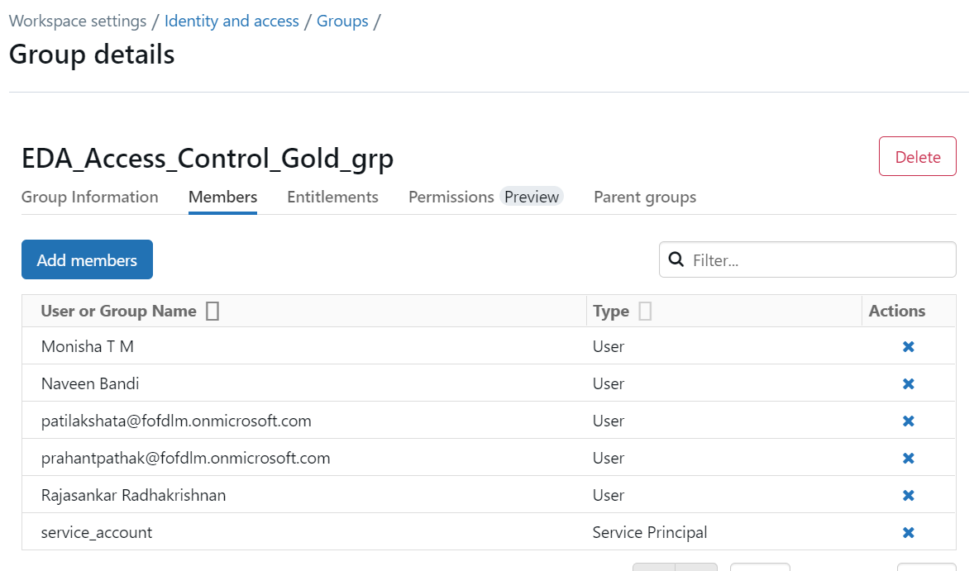

7. Providing Access to user group on Data Object :

Prerequisite:

The user should be part of a user_group.

Access can be provided on Schema, Tables to user groups.

Below are the different access levels available in each of the Objects.

|  |  |  |
| --- | --- | --- |
| **Object type** | **Access Level** | **Description** |
| Table | read | Users or groups will be able to read the data from the table.  Cannot edit data in table  Cannot delete data from table |
| Table | Edit | Users or groups will be able to read the data from the tables under the schema.  Can edit data in table  Can delete data from table |
| Schema | Create | User or group will be able to create tables under the schema |
| Schema | read | user or group will be able to read all the tables under the schema  Cannot edit data in tables under the schema  Cannot delete data from tables under the schema |
| schema | Edit | user or group will be able to read the data from the tables under the schema  Can edit data in tables under the schema.  Can delete data from tables under the schema. |

To provide access on any of the objects to any user groups, please follow the steps below.

1.Open the below notebook

[/Repos/Access control/Access control/Access control/Table Access Control/1.Provide access to User groups on Table,schema,Catalog](https://adb-615732812296608.8.azuredatabricks.net/?o=615732812296608#workspace/Repos%2FAccess%20control%2FAccess%20control%2FAccess%20control%2FTable%20Access%20Control%2F1.Provide%20access%20to%20User%20groups%20on%20Table%2Cschema%2CCatalog)

2.Enter the relevant details in the Widgets of the notebook

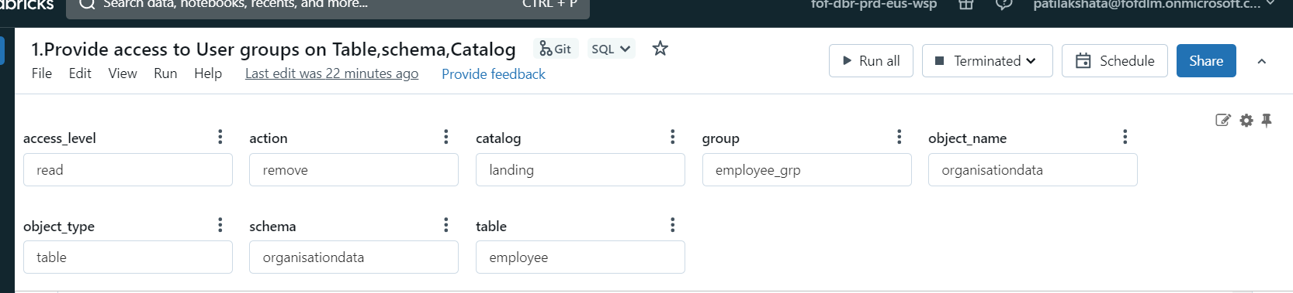

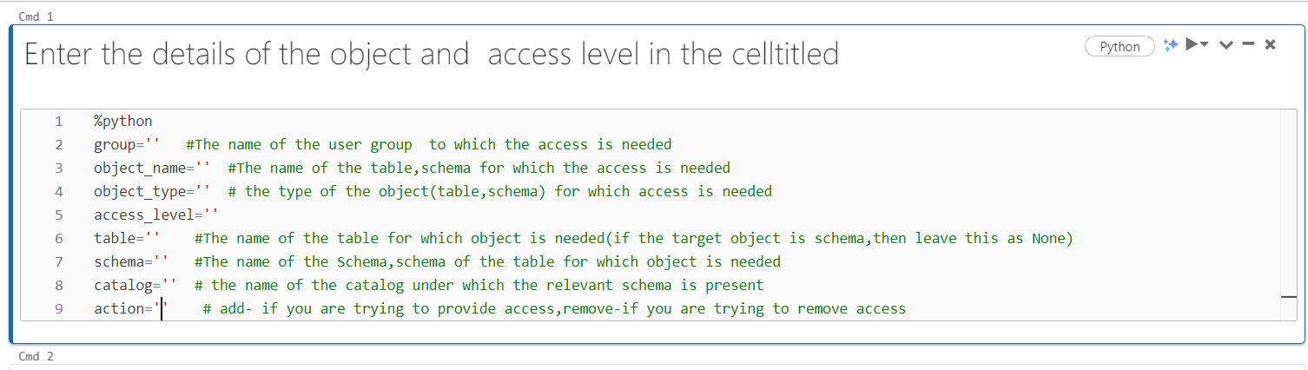

3. Some examples of how to fill the details are given below.

Consider the below scenarios

Below are the unity catalog objects

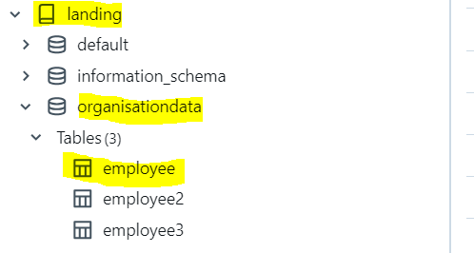

Below are user groups

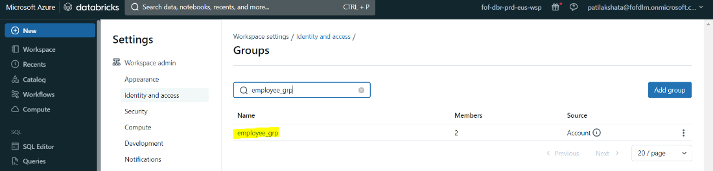

Example a) Providing read access on table “organisationdata” to user group “employee_grp”

The below information should be provided to

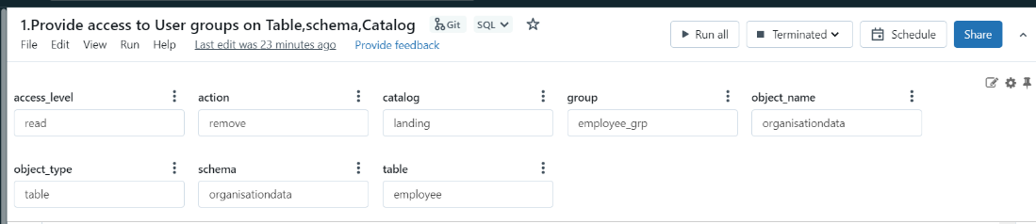

Example b) removing read access on table “organisationdata” from user group “employee_grp”

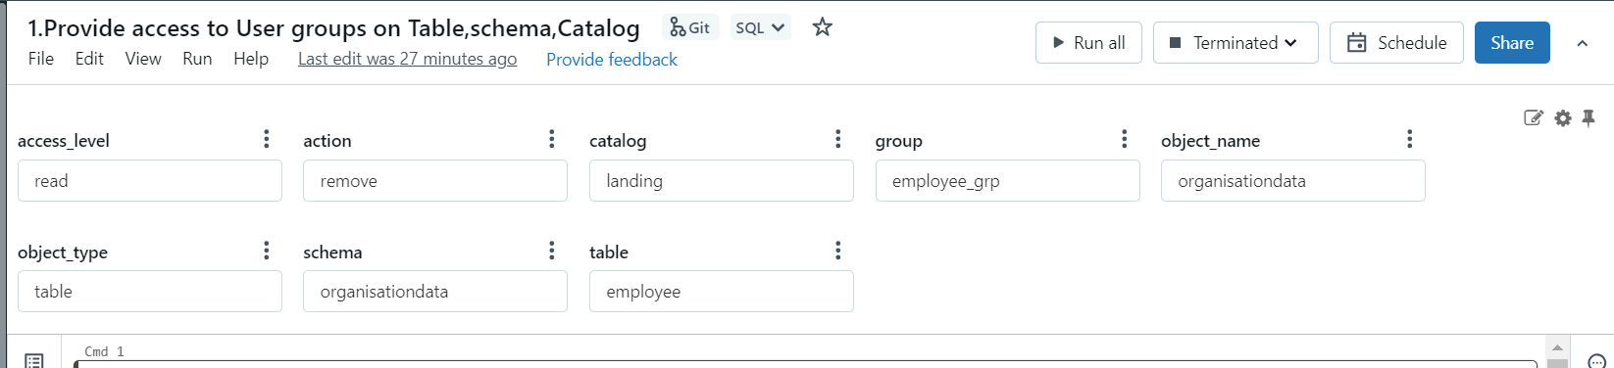

Example c) Providing edit access on table “organisationdata” to user group “employee_grp”.

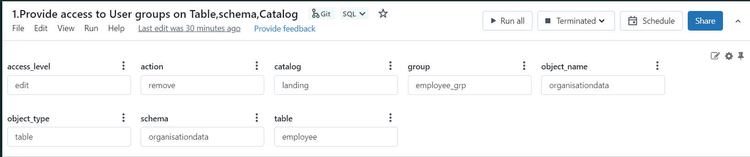

Example d) Providing create access on table “organisationdata” to user group “employee_grp”.

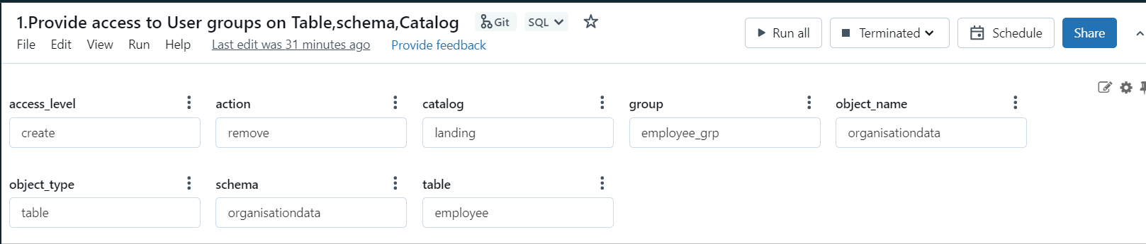

3. Once the relevant information is entered, please run the next commands in the notebook or run the notebook through the job created (JB_TableAccess_Control).

4. the request is now created.

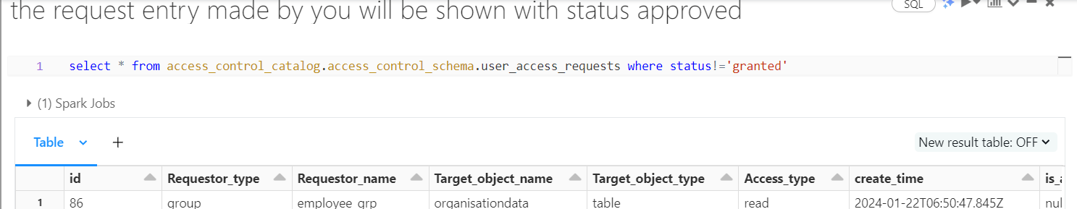

Note: **user_access_requests** table.

The "user_access_requests" table, residing in "Access_control_catalog" catalog and "Access_control_schema" schema, functions as a central repository for managing requests related to adding, editing, or creating access for specific user groups to tables, catalogs, or schemas. These requests are initially marked with a status of "Approved."

Following the completion of the notebook run ("/Repos/Access control/Access control/Access control/4.Table_AccessControlExecutor"), the status undergoes a modification from "Approved" to "granted" for the corresponding table, catalog, or schema. This adjustment reflects the provisioning or revocation of access based on the details specified during the request submission.

Additionally, the table serves a crucial role in audit processes by enabling the tracking of raised requests and documenting permissions granted for specific tables, catalogs, and schemas. This feature enhances transparency, accountability, and the ability to ensure compliance with security policies, making it a valuable tool for maintaining a comprehensive audit trail in access control procedures.

Below is the screenshot of **access_control_catalog.access_control_schema.user_access_requests** table

Crea

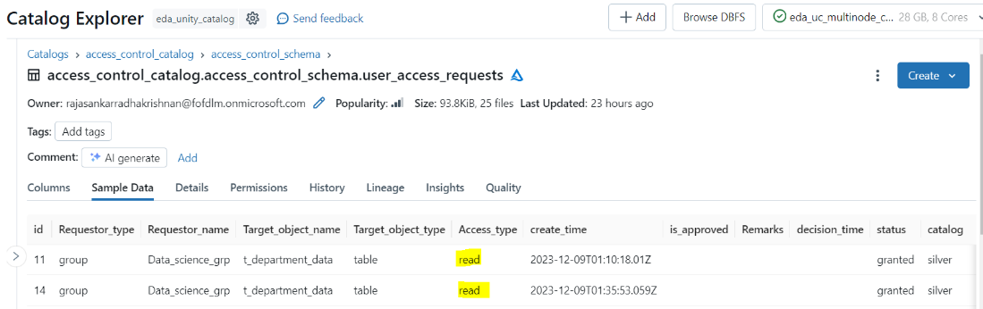

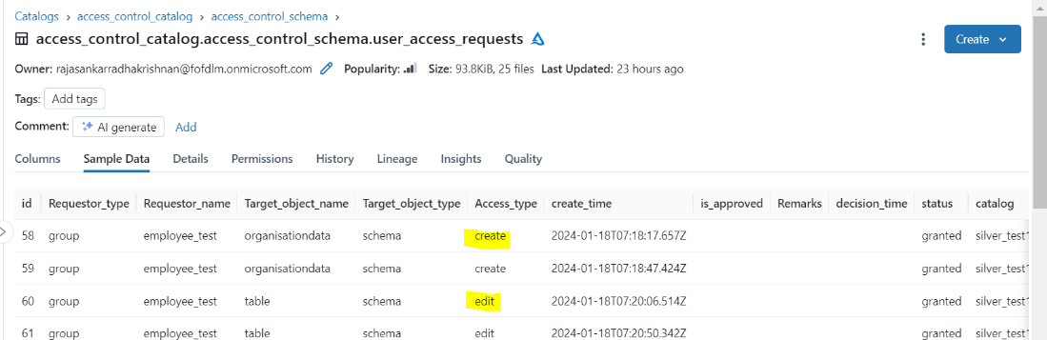

**Sample Output for various scenarios**:

Below is the catalog, schema, table are used for testing.

Catalog: landing

Schema: organisationdata

Table: employee

Pre-requisite: user should be part of employee_grp group

**Sample 1: Testing read access for user.**

Before providing read access to the user added to the group.

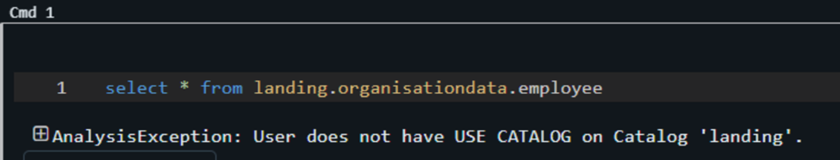

Enter the details of the object and access level in the cell of the notebook, after running the notebook below is the output:

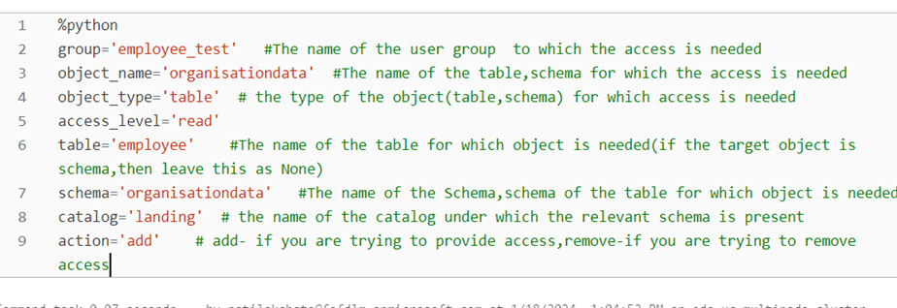

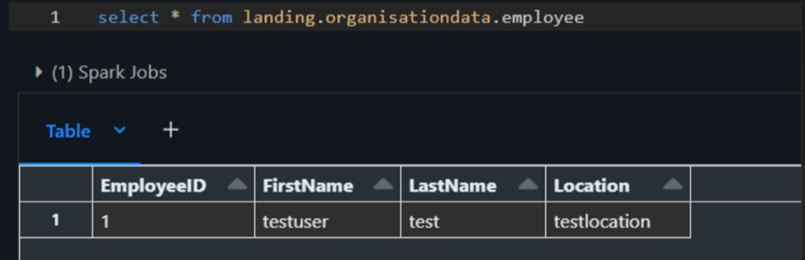

**Sample 2: Testing Edit access for user.**

Before providing insert access to the user added to the group

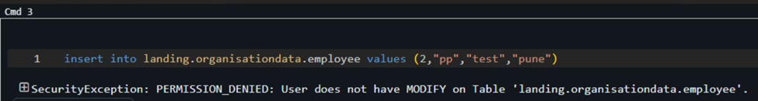

Enter the details of the object and access level in the cell of the notebook, after running the notebook below is the output:

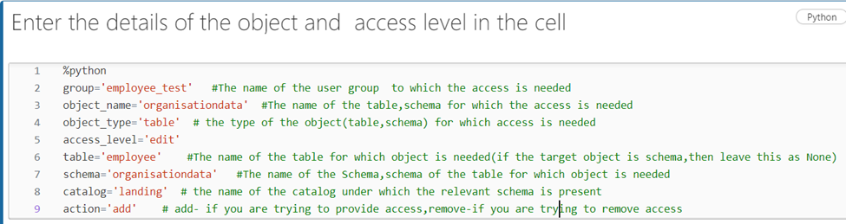

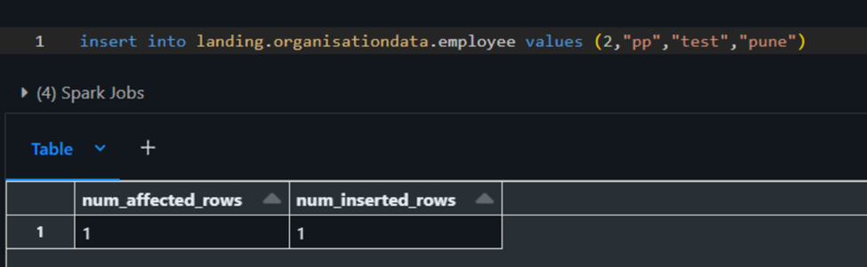

**Sample 3: Testing for Create access for a user:**

Before providing the create access to user added to user group

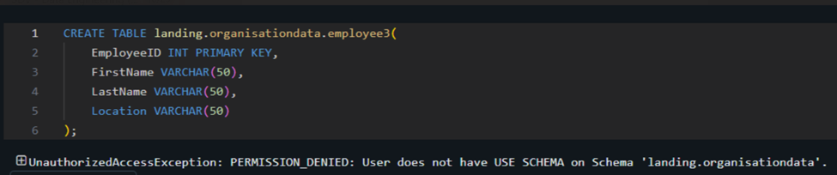

Enter the details of the object and access level in the cell of the notebook, after running the notebook below is the output:

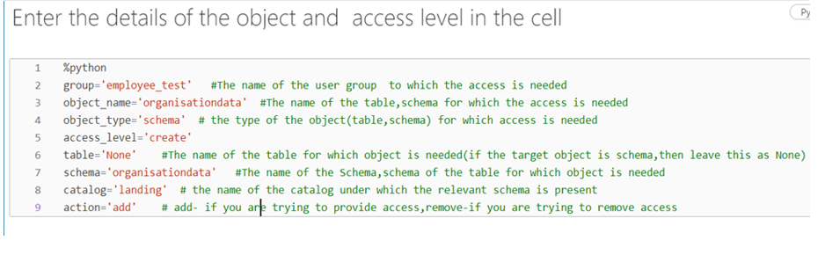

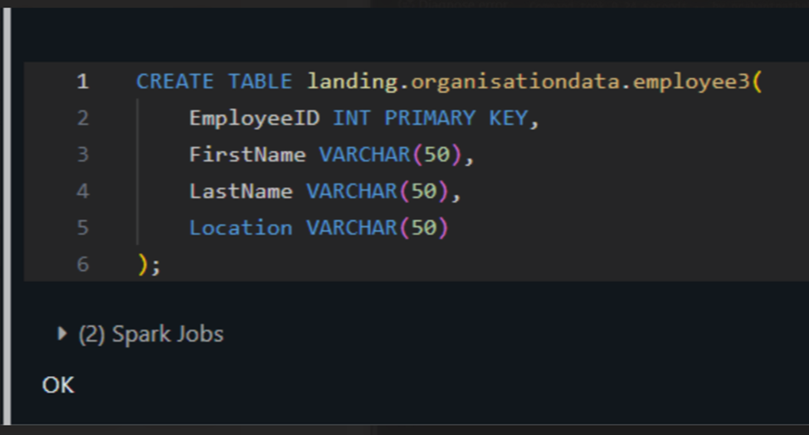

**Sample 4: Removing access to the user on (table/schema/catalog) .**

Before removing the access of a user for a table.

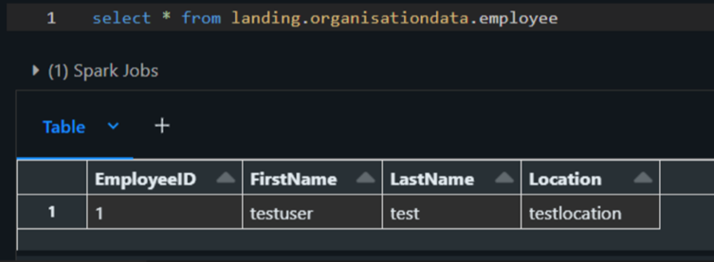

Enter the details of the object and access level in the cell of the notebook, after running the notebook below is the output:

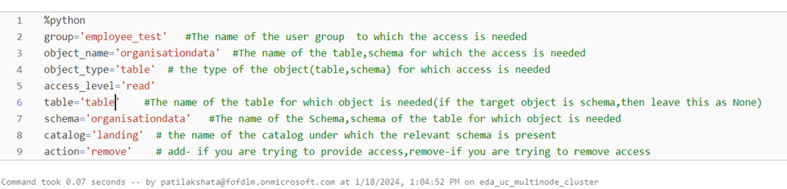

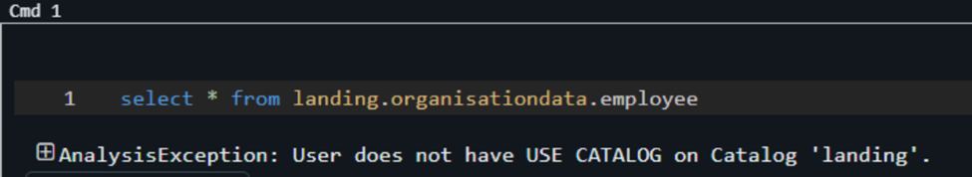

8. Creating Service Account:

1. Create the service principal account by using application Id. 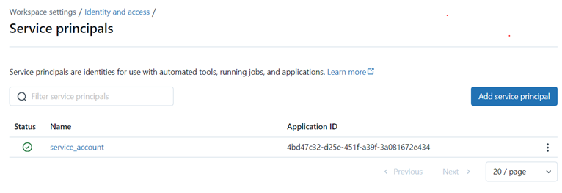
2. Provide the below access to service account under permissions tab.

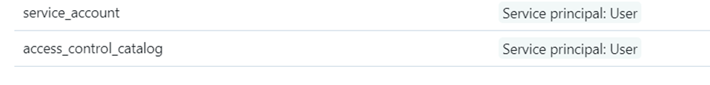

3. Add service account to admins group of data bricks as well.

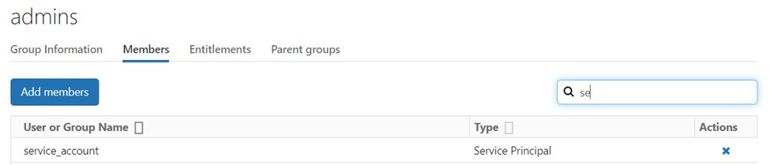

9. Creating job for Service account:

1. Create a job with service account as the owner under the workflow tab and attach the notebook and cluster that has service account added to it under privileges.

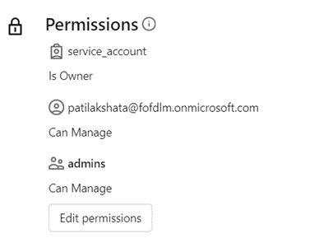

1. Edit the job “Run as” to service account.

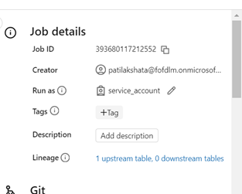

1. Catalog, Schema and the table should also have the service account added to its group and assigned as the owner of the table.

Note: In the example below “EDA_Access_Control_Landing_grp” has service_account added to it.

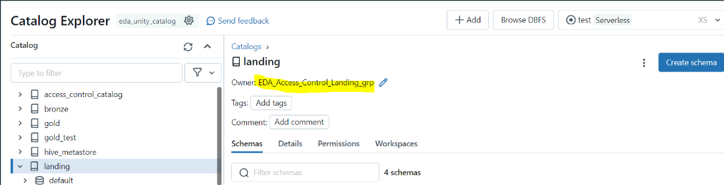

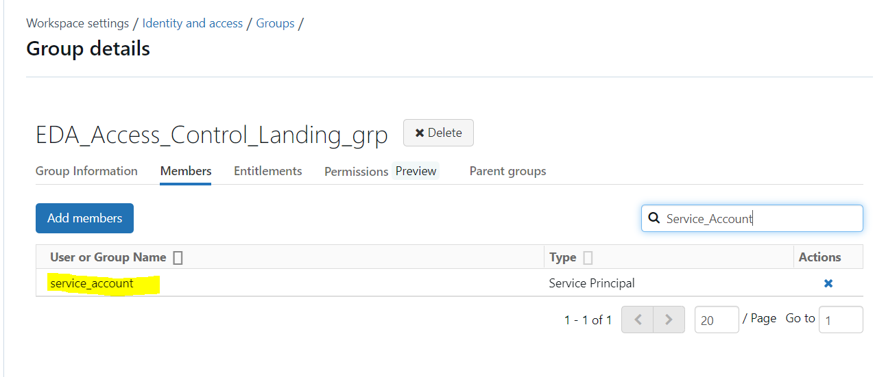

10. Testing RLS and CLS after running the jobs:

1. Run the notebook (/Repos/Access control/Access control/Access control/Table Access Control/2.Providing RLS) or the job (Jb_RLS):

Sample:

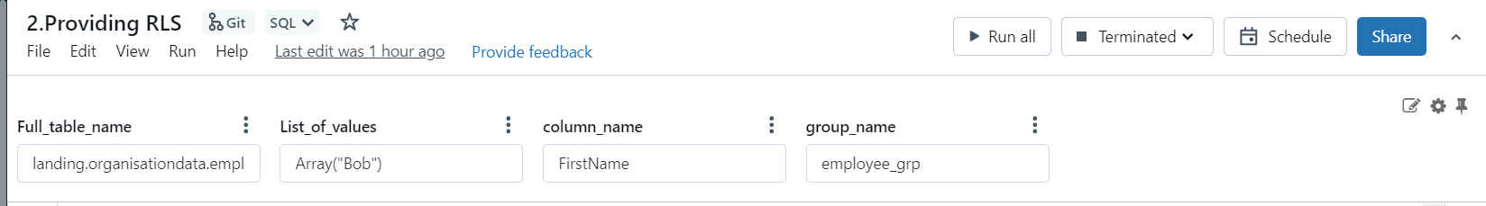

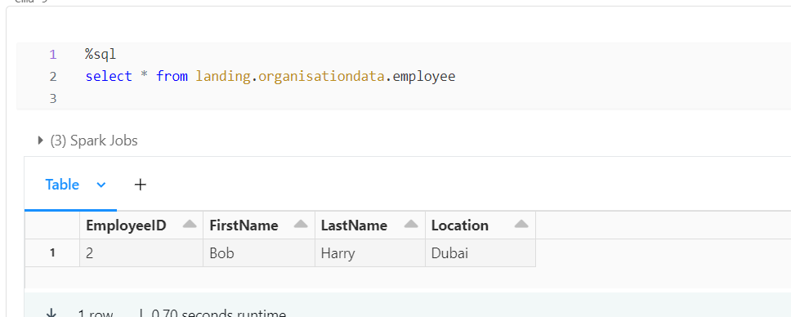

Note: **rlsconfig** table:

The "Access_control_catalog" catalog and "Access_control_schema" schema host a pivotal configuration table referred to as "rlsconfig." This central table is designed to encompass essential information, including tablename, columnname, groupname, and filtervalue.

Users contribute values to this table, specifying the necessary parameters for implementing Row-Level Security (RLS). Following the execution of the code ("/Repos/Access control/Access control/Access control/5.RLS_CLS_Access control SQL executor"), the code dynamically retrieves values from the "rlsconfig" table. Subsequently, it applies RLS to the specified table, filtering data based on the values specified in the "rlsconfig" table. This dynamic process ensures effective and adaptable Row-Level Security tailored to the parameters set by users in the configuration table.

1. Below attached is the screenshot of **access_control_catalog.access_control_schema.rlsconfig** table.

Cre

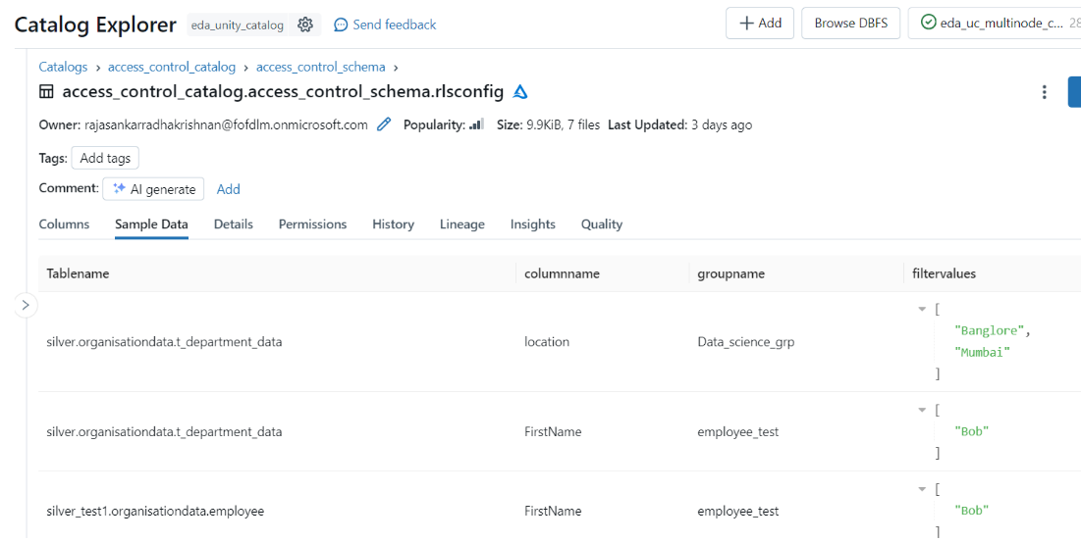

1. Run the notebook (/Repos/Access control/Access control/Access control/Table Access Control/3.Providing CLS) or the job (Jb_CLS):

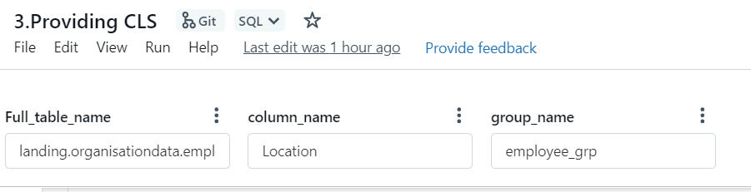

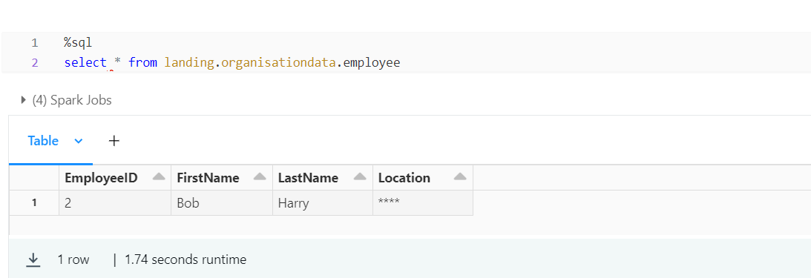

Note: **clsconfig** table:

The "Access_control_catalog" catalog and "Access_control_schema" schema host a pivotal configuration table referred to as "clsconfig." This central table is designed to encompass essential information, including tablename, columnname and groupname.

Users contribute values to this table, specifying the necessary parameters for implementing Column-Level Security (CLS). Following the execution of the code ("/Repos/Access control/Access control/Access control/5.RLS_CLS_Access control SQL executor"), the code dynamically retrieves values from the "clsconfig" table. Subsequently, it applies CLS to the specified table, masking data based on the values specified in the "clsconfig" table. This dynamic process ensures effective and adaptable Column-Level Security tailored to the parameters set by users in the configuration table.

**Below attached is the screenshot of** **access_control_catalog.access_control_schema.clsconfig** table**.**

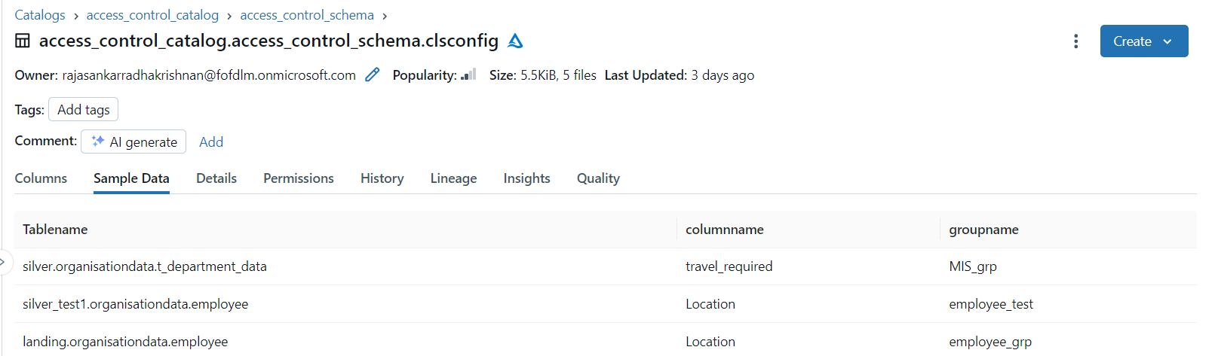

11. ETL Pipeline Changes

For ETL pipeline Changes Please refer below Document

[ETL pipeline changes](https://bosch.sharepoint.com/sites/msteams_2036456/_layouts/15/Doc.aspx?sourcedoc=%7BD53EC26B-90B5-4E31-A631-241B1835A53C%7D&file=code%20changes%20unity%20catalog.docx&action=default&mobileredirect=true&DefaultItemOpen=1)

12. Extended Insights: Exploring Advanced Cluster Options:

12.1 Creation of Interactive Cluster(shared):

Creation of Multinode cluster(Shared):

Note : We're setting up an interactive cluster(shared) to enhance data security and access control. This will enable shared access, crucial for tasks like Row-Level Security (RLS) and Cluster-Level Security (CLS)

12.1.1 On left side of the Databricks menu list, click on the compute for the creation of Multinode cluster:



12.1.2 Go to, Compute -> Create Cluster.

Click on Create compute



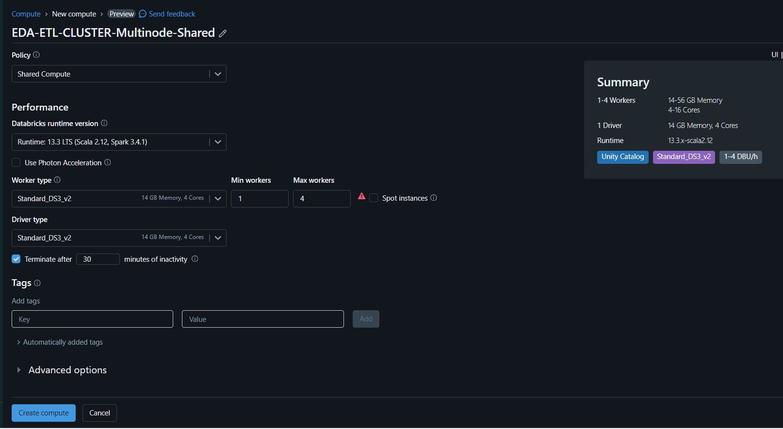

Enter the details and configurations of the Clusters.

* Name - <projectname>-ETL-CLUSTER-Multinode-Shared
* Access mode - Shared
* SKU – Standard_DS3_v2 (worker type)
* Standard_DS3_v2(Driver type)

**Note**: Access mode no isolation shared will not enable unity catalog

In Advanced option add below line :

spark.hadoop.fs.azure.account.key.<STORAGEACCOUNTNAME> <ACCESS_KEY>

Note: - Access key of storage account

spark.executor.defaultJavaOptions -XX:+G1HeapRegionSize

spark.driver.defaultJavaOptions -XX:+G1HeapRegionSize

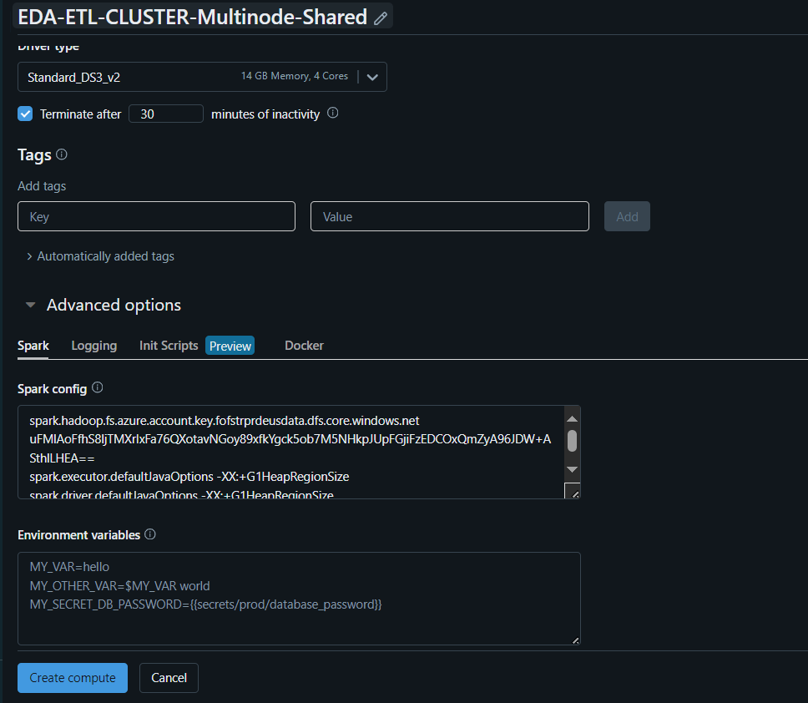

12.1.3 After the creation of cluster, click on the cluster and go to libraries tab.

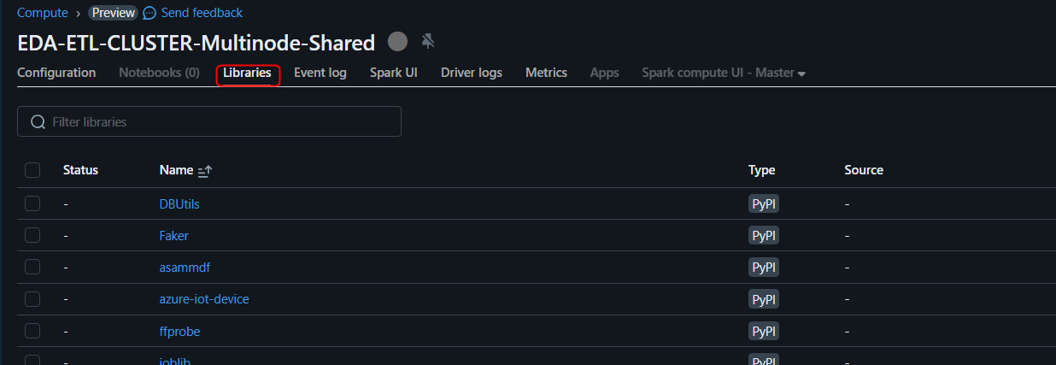

12.1.4 Click on libraries after creation of cluster.

Click on Install new.





Click on install new -> Select PyPI as Library Source.

Enter msal as the package name -> Install.

Now, the msal library has been installed in the cluster.

Follow above steps for installation of libraries to install the remaining libraries that are listed below.

|  |  |  |
| --- | --- | --- |
| Libraries | Latest Version | Source |
| Asammdf | 7.3.14 | PyPI |
| azure-iot-device | 2.12.0 | PyPI |
| DBUtils | 3.0.3 | PyPI |
| Faker | 19.2.0 | PyPI |
| Ffprobe | 0.5 | PyPI |
| Joblib | 1.3.1 | PyPI |
| Mlflow | 2.5.0 | PyPI |
| Tinytag | 1.9.0 | PyPI |
| Pymediainfo | 6.0.1 | PyPI |
| SciPy ==1.10.1 | 1.10.1 | PyPI |
| sentence-transformers==2.2.2 | 2.2.2 | PyPI |
| Tensorflow | 2.13.0 | PyPI |
| Transformers==4.24.0 | 4.24.0 | PyPI |
| moviepy | 1.0.3 | PyPI |

In the context of setting up a multinode shared cluster with Unity catalog enabled, you may encounter a security exception when attempting to retrieve connection details for a database. This issue arises during the execution of scripts that call the **fn_get_connection_details** function from the common functions repository.

To address this security exception, a workaround is implemented by opting for a job cluster. This job cluster is configured to be multinode and operates in a single-user mode. The decision to use a job cluster is driven by the limitation in shared mode, which restricts access to only one user at a time.

This solution allows for smoother retrieval of connection details without encountering the security exception, ensuring efficient and uninterrupted access to the database. The job cluster's configuration facilitates better handling of multiple nodes and ensures a dedicated user experience, mitigating the issues associated with shared mode.

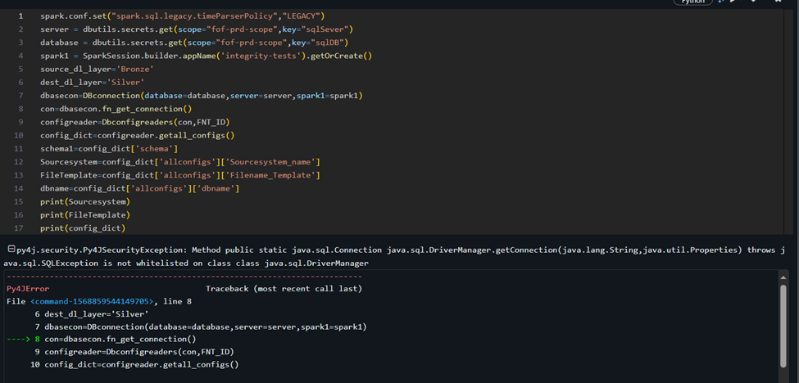

py4j.security.Py4JSecurityException: Method public static java.sql.Connection java.sql.DriverManager.getConnection(java.lang.String,java.util.Properties) throws java.sql.SQLException is not whitelisted on class class java.sql.DriverManager

- py4j.security.Py4JSecurityException: Method public static java.sql.Connection java.sql.DriverManager.getConnection(java.lang.String,java.util.Properties) throws java.sql.SQLException is not whitelisted on class class java.sql.DriverManager at py4j.security.WhitelistingPy4JSecurityManager.checkCall(WhitelistingPy4JSecurityManager.java:473) at py4j.Gateway.invoke(Gateway.java:305) at py4j.commands.AbstractCommand.invokeMethod(AbstractCommand.java:132) at py4j.commands.CallCommand.execute(CallCommand.java:79) at py4j.ClientServerConnection.waitForCommands(ClientServerConnection.java:195) at py4j.ClientServerConnection.run(ClientServerConnection.java:115) at java.lang.Thread.run(Thread.java:750)

12.2 Creation of Job Cluster:

Creation of Multinode Job cluster:

12.2.1 Open Azure Data Factory and go to manage section:



12.2.2 Go to Linked services -> Click on + New.



12.2.3 Go to Compute and select Azure Databricks.



12.2.4 Provide details as shown below and select cluster as New job cluster.

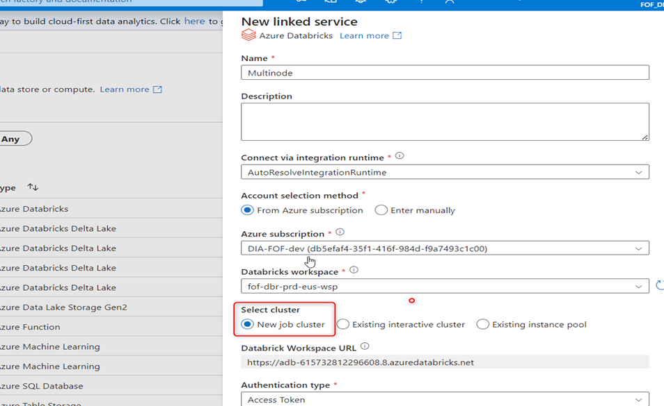

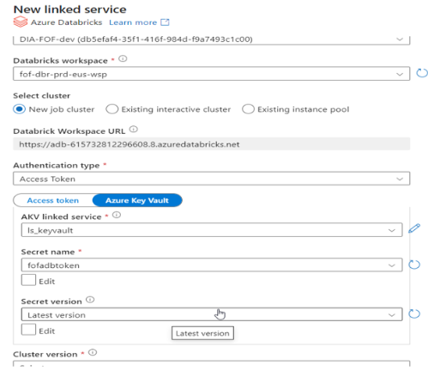

Select cluster version as 13.3 LTS

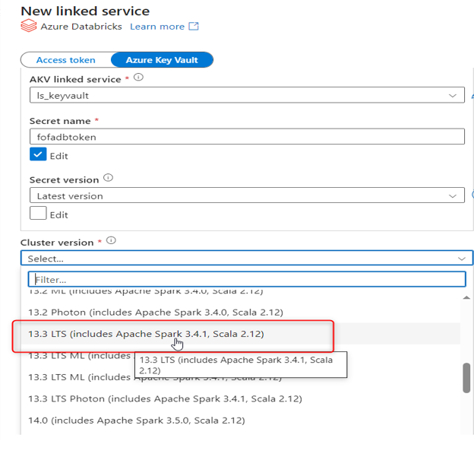

Enter the details and configurations of the Clusters.

* Cluster version : 13.3 LTS (includes Apache Spark 3.4.1, Scala 2.12)
* Cluster node type : Standard_DS3_V2
* Python version : 3
* Worker options : Autoscaling (min workers -1 and max workers - 4)

Then click on create button.

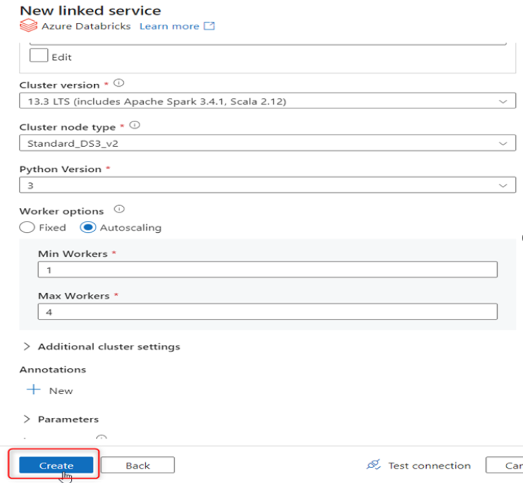

12.2.5 Then go to your pipeline which you want to run.

Click on Author -> Select pipeline pl_Bronze_to_Silver.





12.2.6 Click on Notebook activity ->Azure Databricks -> Select your linked service.

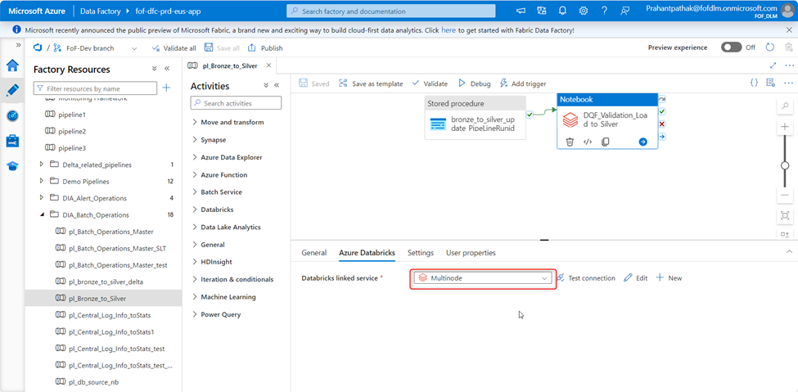

12.2.7 Provide libraries name which you want to install in your job cluster in append libraries section.

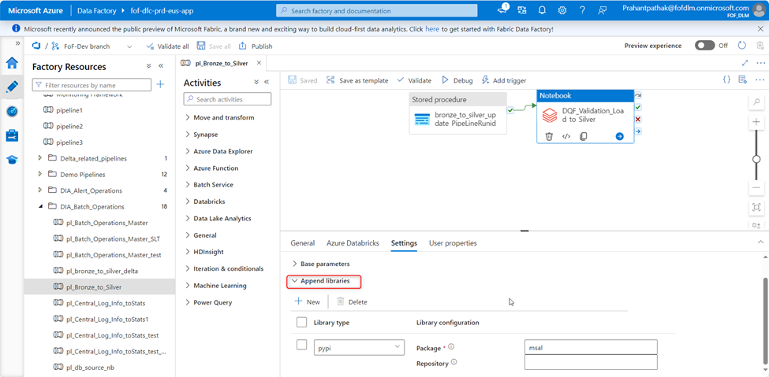

Creation of Single node Job cluster:

12.2.8 Open Azure Data Factory and go to manage section:



12.2.9 Go to Linked services -> Click on + New.



12.2.10 Go to Compute and select Azure Databricks.



12.2.11 Provide details as shown below and select cluster as New job cluster.

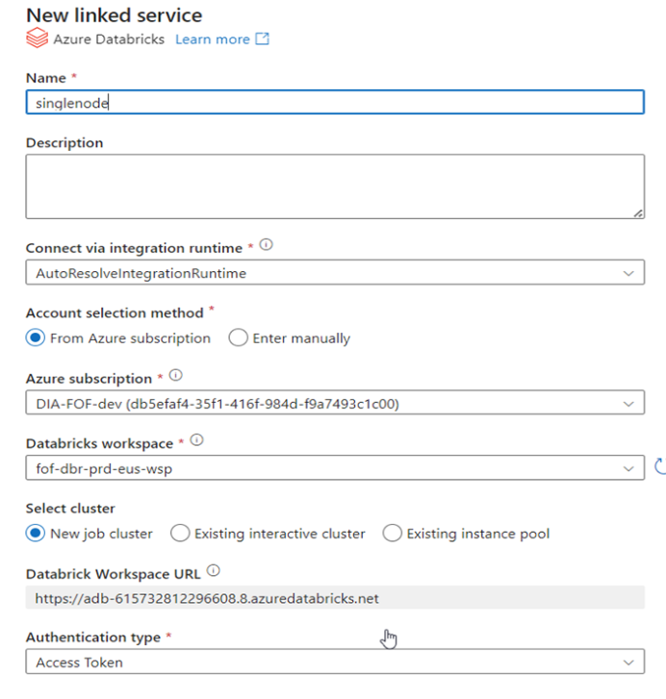

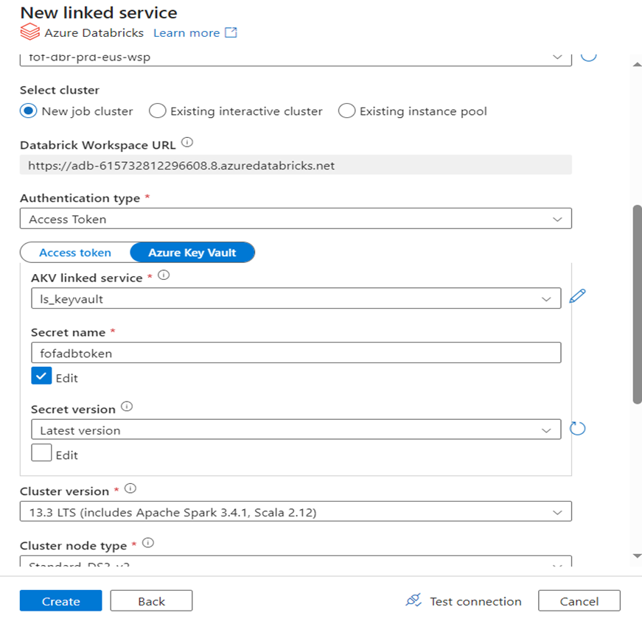

Enter the details and configurations of the Clusters.

* Cluster version : 13.3 LTS (includes Apache Spark 3.4.1, Scala 2.12)
* Cluster node type : Standard_DS3_V2
* Python version : 3
* Worker options : Fixed ( workers -1 )

Then click on create button.

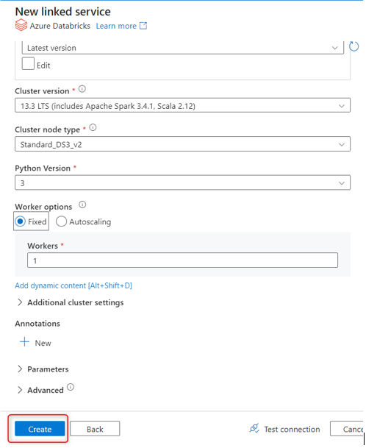

12.3 Cluster Pools

12.3.1 Go to compute and then click on Pools tab.

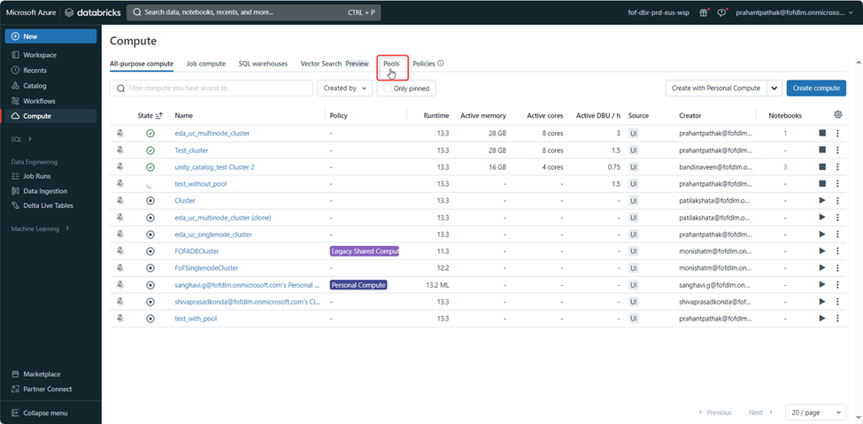

12.3.2 Click on create Pool.

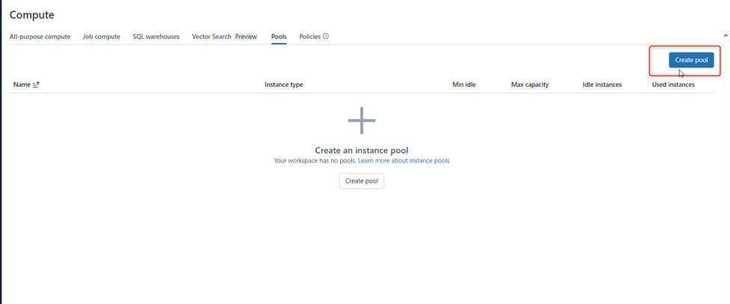

Fill details for the shared pool as shown below.

Note: Auto-termination is not applicable for idle instances; they will continue to run, incurring costs. It is advisable to delete the pool once all jobs are completed.

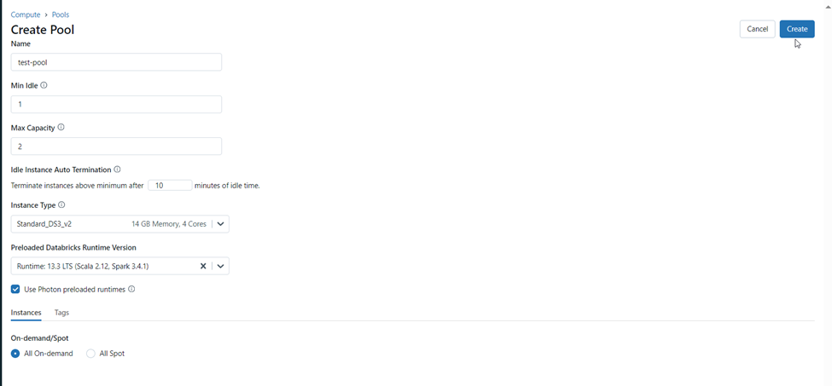

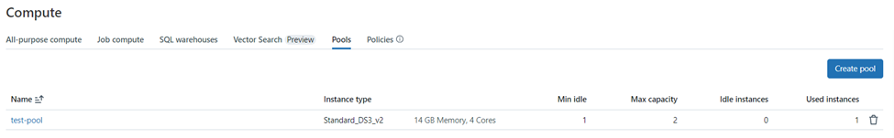

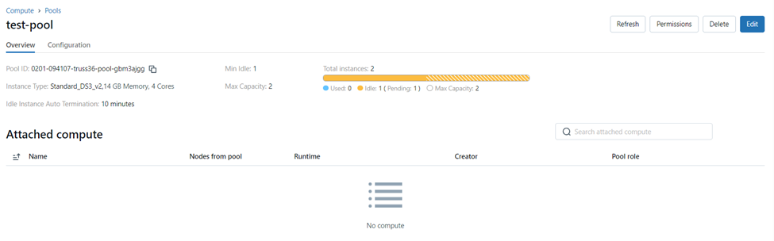

12.3.3 Configure a cluster that utilizes pool instances, specifying the node type as a shared pool with the name "test-pool," which was previously created, and select it from the dropdown menu.

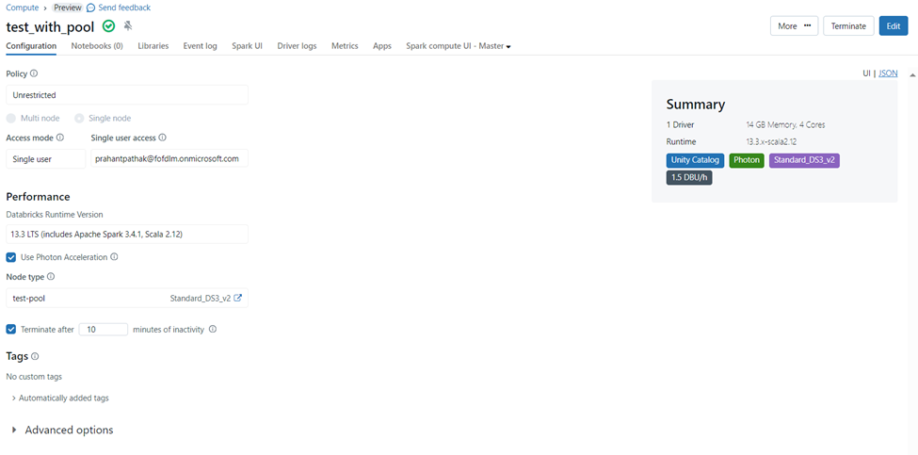The cluster mentioned above utilizes instances from the pool, resulting in a total of 1 used instance and 0 idle instances, as the maximum specified instances for the pool are set to 2.

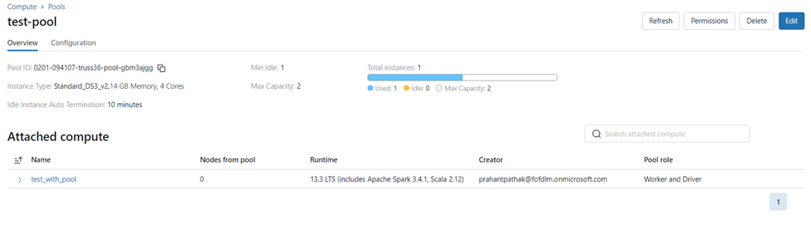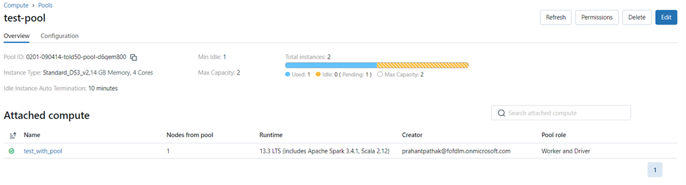

The cluster created using a pool demonstrates significantly reduced processing time compared to a cluster created without a pool.

